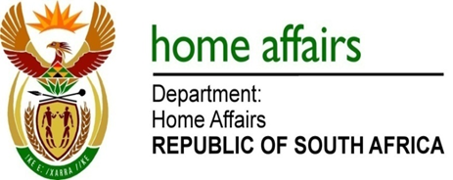

NATIONAL ASSEMBLY

QUESTION FOR WRITTEN REPLY

QUESTION NO. 2633

DATE OF PUBLICATION: FRIDAY, 1 SEPTEMBER 2017

INTERNAL QUESTION PAPER 31 OF 2017

2633. Ms S V Kalyan (DA) to ask the Minister of Home Affairs:

Was notice of an RSA05 clearance for the flight that (a) arrived at Waterkloof Air Force Base from Harare on or about 16 August 2017 and (b) departed from Waterkloof Air Force Base to Harare on or about 20 August 2017 received by her department; if so (a) who approved the clearance and (b) on what basis was the clearance done? NW2939E
REPLY:

The Department of Home Affairs is not responsible for the clearance of any flights.

Remarks: Reply: Approved / Not Approved

Mkuseli Apleni Prof. Hlengiwe Mkhize, MP
Director-General Minister of Home Affairs
Date: Date:

