MINISTRY: JUSTICE AND CORRECTIONAL SERVICES

REPUBLIC OF SOUTH AFRICA

NATIONAL ASSEMBLY
QUESTION FOR WRITTEN REPLY
PARLIAMENTARY QUESTION NO: 2631
DATE OF QUESTION: 26 AUGUST 2022
DATE OF SUBMISSION: 09 SEPTEMBER 2022
Adv G Breytenbach (DA) to ask the Minister of Justice and Correctional Services:
(a) What (i) was the initial (aa) projected cost and (bb) envisaged completion date of the Integrated Justice System and (ii) has been the total cost of development of the Integrated Justice System to date and (b) on what date is the Integrated Justice System envisaged to be (i) completed and (ii) rolled out to all courts in the Republic?
NW3147E
REPLY:

With regards to the Integrated Justice System (IJS) initial projected costs, as a way of giving background/overview of the IJS Programme, the Programme was conceptualised upon approval of the National Crime Prevention Strategy by Cabinet in 1996 to modernise the Criminal Justice System (CJS).

The IJS Programme was further given impetus by:
- Review of the Criminal Justice System – “The seven-point plan” (2007)
- Outcome 3 of the JCPS Cluster Delivery Agreement - “All people in South Africa are and feel safe”
- National Development Plan (NDP vision 2030)

The primary objective of the IJS is to transform South Africa’s CJS into a modern, efficient, effective & integrated system by:
- Electronically enabling and integrating the end-to-end criminal justice business processes (i.e. from the report of a crime to the release of a convicted person), through technology solutions; and
- Managing the related inter-departmental information exchanges across the CJS

Eight government departments, agencies and authorities are involved in the criminal justice value chain, from the time a crime is detected or reported, through to investigation, prosecution and delivery of justice.

The implementation strategy of the IJS Programme has been divided into three steps to facilitate an effective modernisation process whilst realising early benefits:
Step 1: Creating departmental system capacity to automate business process flow;
Step 2: Integrating the criminal justice business processes; and
Step 3: Instrumentation of the criminal justice process to manage identified key
performance indicators.
One of the focus areas of the Programme has been building sufficient capacity in areas of forensic services, detective services and prosecution services to support our efforts to reduce the overall levels of crime, particularly “contact” crimes.

To improve the efficiency and effectiveness of the end-to-end CJS, extensive enabling department capacity building has been undertaken by the IJS programme. The benefits from system modernisations and case workflow integrations are only realised when pre-requisite departmental systems and ICT infrastructure is in place.

Inter-Departmental Information exchanges
It is also important to note that IJS is not a system but a programme comprising of multiple projects across eight CJS member departments. The IJS also has what is called the Transversal Hub. The Transversal hub manages the related inter-departmental information exchanges across the CJS member departments.

Currently, ten (10) government departments/entities (South African Police Service, National Prosecuting Authority, Department of Justice and Constitutional Development, Office of the Chief Justice, Department of Correctional Service, Department of Home Affairs, Department of Social Development, Legal Aid South Africa, SASSA, and RTMC) are connected to the IJS hub and able to electronically exchange information. The Hub allows electronic information sharing to reduce administrative delays, enabling the various justice service providers to respond efficiently and provide tools for the effective management and planning of the criminal justice system

For the implementation of a fair and just system to be successful, efficient and effective, a cohesive integrated capability is required that considers the processes, policies, application systems and people across the CJS

With regards to initial costing of IJS:
There is no initial costing of the IJS programme. When one looks at the nature of the programme, it comprises of several initiatives from the eight (8) member departments forming part of the CJS. The annual programme costing is done by following a specific budgeting process which is repeated every financial year and it works as follows:
- Each member department submits a list of projects (Infrastructure modernization, application development etc.) that it plans to undertake in the following financial year.
- IJS Project Management Office (PMO) then analyses these projects to determine relevance and value add to the CJS.
- IJS through IJS Implementation Committee and IJS Board of Directors-General (DGs) then approves or declines, and once approved, the list of projects is then sent to National treasury to obtain funding. Once funding is obtained, project execution is undertaken (refer to the New IJS Governance Framework).

With regards to Completion date of the IJS Programme:
At this point in time, the IJS programme does not really have an end date due to the following:
- Businesses evolve. As a results, business processes also must be reengineered, resulting in a need for applications/systems supporting these processes to be enhanced, in some cases, built from scratch.
- Continuous Infrastructure Modernization is key to the IJS to ensure systems developed support key/core business processes and that they are used optimally.
- Enhancement and maintenance of current case management systems and development of new persons’ management system in line with the 4IR stack remains a continuous priority.

On what date is the IJS envisaged to be rolled out to all courts in the republic:
It should be noted that the IJS is a programme comprising of multiple projects from eight member departments. To date, case management business applications have been developed and implemented for almost all eight member departments (including DoJ&CD) with exception of the OCJ which is currently piloting its Court Online application in the Johannesburg and Pretoria High Courts, national roll out is planned for the current financial year.

Some IJS key initiatives that have been rolled out to courts in the republic include:
A strategic IJS modernisation project which seeks to transform the management, handling and sharing of records. The Office of the Chief Justice (OCJ) Court Online System provides a platform for law firms and litigants to file documents to the courts electronically, via the Internet. Modernisation of traditionally paper-intensive manual processes realises significant efficiency benefits. Beyond minimising the physical movement of people and paper court documents from parties to the Courts, it also leverages the benefits of electronic storage including faster document filing and retrieval, eradication of the misplacement of case files, and allows concurrent access to view the same case file by different parties.

The first component of the solution enabled the digitalization of evidence in the court. This enables a fully digital version of the case bundle (including all filed court documents) to be made available electronically to all the relevant parties.

On 18 July 2019, a key milestone was reached through the undertaking of the first fully paperless case trial simulation. All parties in court were able to use their own laptops and/or mobile tablets (iPads) to access and refer to digital versions of case materials. The solution enables each party to record notes and annotations, highlight and redact content as needed, and choose whether notes and annotations be shared, or kept private.

The digital case bundle pilot at Johannesburg High Court and Pretoria High Court was completed successfully and the digital case bundle has been operationalised (rolled out to production) at both these two sites. The project has established a centralised Court Online helpdesk to provide support to both internal stakeholders (judges and court officials) and external stakeholders (legal practitioners).

Recently, the IJS and OCJ completed development for the second component which is the main engine (CRM dynamics) was completed successfully in 2021/22 financial year. Pilot for the end-to-end court online solution commenced in March 2022 in Johannesburg High Court, thereafter it was extended to the Pretoria High Court. National roll-out is planned for quarter 3 of 2022/23 financial year.

The IJS and OCJ has also rolled out critical infrastructure on all high courts national in preparation for the Court online rollout. This included Servers, Network Switches, Wi-Fi Upgrade, Provisioning of the Uninterrupted Power Supply (UPS) for Server and Patch Rooms for all Service Points, etc.

Court Audio Visual Solution for Case Participants: This is a court audio visual solution that is used for witnesses/victims’ interview and testimony in cases where direct contact is not feasible or very expensive, as well as in cases where expert witnesses are required in court. This also allows victims and witnesses to easily get in touch and communicate with the CJS practitioners that are responsible for their case. This is related specifically to virtual court appearances integrating to court recording solution for the court record. In the last financial year, IJS completed the national roll-out to eighteen (18) sites.

In July 2017, the Department of Justice & Constitutional Development (DoJ&CD) completed development, testing and implementation of the enhancements to its Integrated Case Management System (ICMS) to enable the electronic generation of the J7 Warrant of Detention. This has been successfully deployed to production and is currently active nationally. It should be noted that the paper based J7 will not be eliminated until the mechanism for digital signature is established and this is in the pipeline, already the electronic exchange of this information from DoJ&CD to DCS introduces efficiencies by eliminating the need for DCS to recapture information during the admission & receipt process.

As part of its quest to modernise the CJS infrastructure so as to minimise downtime and lay the foundation for a fully digitised criminal justice system, IJS recently invested in the DoJ&CD data centre upgrade project. This will ensure that the current capacity in the data centre (storage, processing, etc.) is upgraded in order to archive data produced by various solutions (e.g. CRT, ICMS, etc.), thereby improving operational processing and data governance.

IJS will continue to modernise Courts in the republic by:
- Upgrading all infrastructure that has reached end of life; and
- Developing and implemented applications to support court processes.

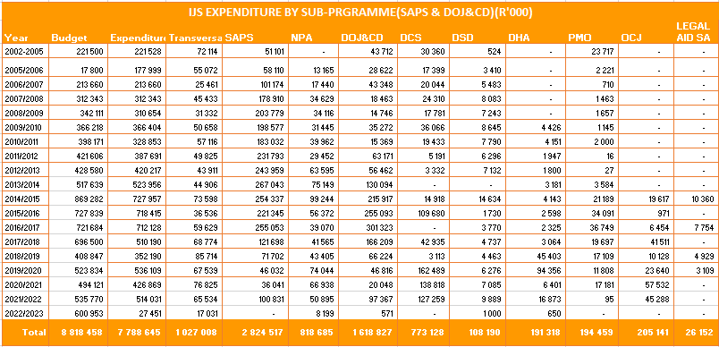
IJS overall spending

The overall spending of the IJS programme from 2002 to March 2022 is ± R7.7 billion. However, the following should be noted:
- Total spending is across all eight (8) IJS member departments for various projects relating to CJS person integration; Case management systems; Business Intelligence; and Infrastructure Modernization. It also includes IJS transversal Hub integration projects and maintenance initiatives (daily, weekly, and monthly).
- The IJS programme comprises of an average of approximately 40 – 50 projects on an annual basis across all CJS member departments.
END

