**NATIONAL ASSEMBLY**

**QUESTION FOR WRITTEN REPLY**

**QUESTION NUMBER:** **2631[NW3345E]**

**2631. Ms B M van Minnen (DA) to ask the Minister of Finance:**

With reference to the presentation by the Special Investigating Unit to the Standing Committee on Public Accounts on 20 October 2020, (a) what are the reasons that the municipal-level data on COVID-19 relief funds expenditure for April 2020 to August 2020 was not available at the time of the report, even though data on expenditure related to COVID-19 for 15 March 2020 to 2 October 2020 was already available on municipal level and (b) on what date will the municipal-level data on COVID-19 relief funds expenditure for April 2020 to August 2020 be available?

NW3345E

**REPLY**:

1. According to the report from the presenters to the Standing Committee on Public Accounts, the information was available in the presentation pack. The graphs attached as an Annexure to this response illustrates the COVID-19 expenditure per category (Graph 1), expenditure by municipalities (Graph 2) and expenditure per province (Graph 3).
2. The information is available in the Annexure as Graph 1, 2 and 3 attached. National Treasury introduced a weekly reporting mechanism to track COVID-19 related expenditure. These numbers are not verified numbers. The 4th Quarter ending June 2020, Section 71 of MFMA report presents verified numbers and is published on the Treasury website and can be accessed on the link:

[**http://mfma.treasury.gov.za/**](http://mfma.treasury.gov.za/)

In addition, the National Treasury issued MFMA Circular 105 to municipalities on 25th of August 2020 which introduced further reporting requirements that municipalitiesmust adhere to, these are specific to procurement at the transaction level data. This circular requires municipalities to report on all their COVID-19 transactions on supplier level and items bought. The reports, received from the municipalities, are imported into the data warehouse and published on the Treasury website and can be accessed on the link:

[**http://ocpo.treasury.gov.za/COVID19/Pages/Reporting-Dashboard.aspx**](http://ocpo.treasury.gov.za/COVID19/Pages/Reporting-Dashboard.aspx)

**Annexure**

**Graph 1**

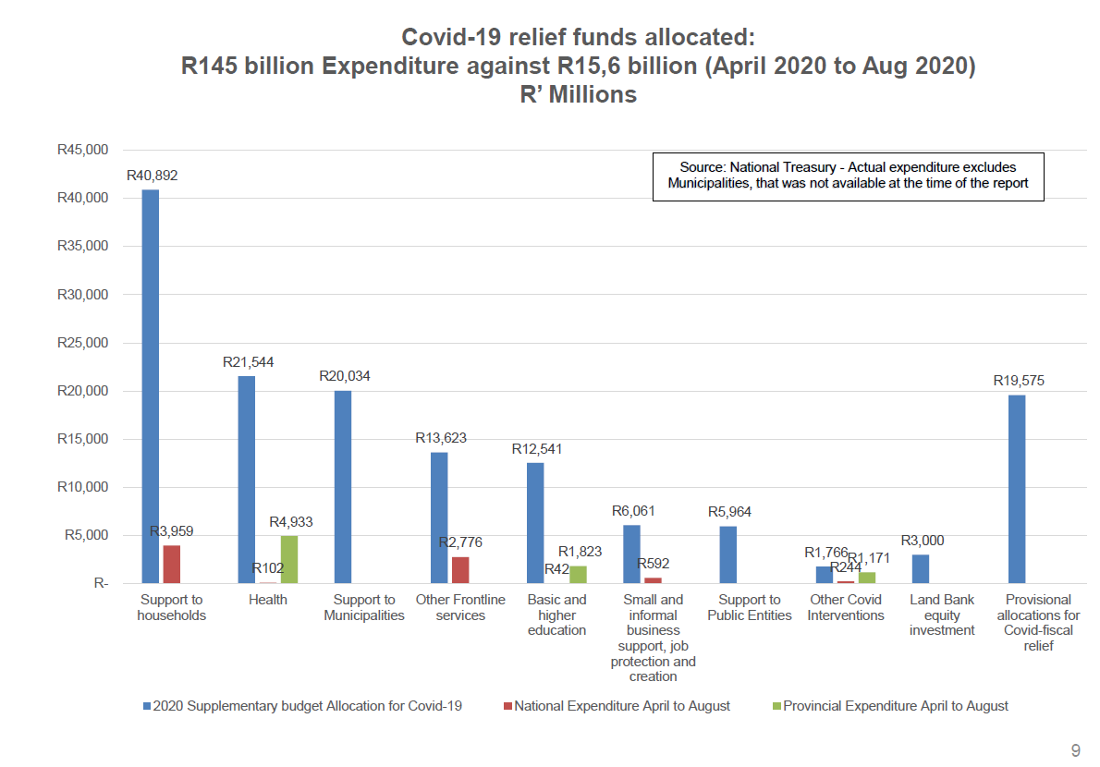

**Graph 2**

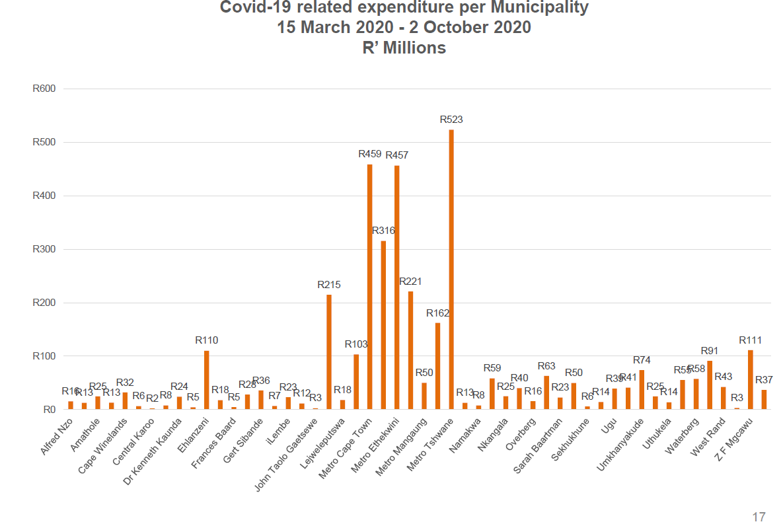

**Graph 3**

