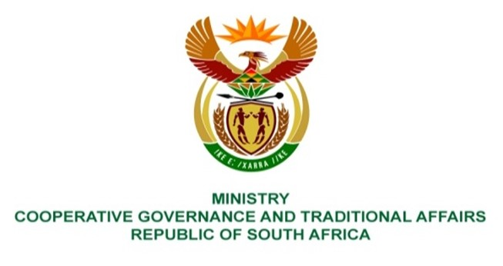

NATIONAL ASSEMBLY
QUESTION FOR WRITTEN REPLY

QUESTION NUMBER NO 263
DATE OF PUBLICATION: 18 FEBRUARY 2022

QUESTION:

263: Mr K Ceza (EFF) to ask the Minister of Cooperative Governance and Traditional Affairs:

Taking into account the depth of decay at the Amahlathi Local Municipality, which has led to the municipality being unable to deliver any sort of services, what are the reasons that the municipality has been left on its own without any intervention from either the provincial or national government? NW243E

REPLY:

The Eastern Cape Executive Council intervened in the affairs of Amahlathi LM in March 2019 in terms of section 139(1)(b) and (5) of the Constitution due to financial crisis and failure by the municipality to provide basic services. The intervention was revoked in November 2019, and an Administrator’s close-out report indicated both progress and outstanding challenges remaining. The recommendations from the Administrator’s report was for the remaining challenges, post the revocation, must be dealt with by the province in providing support to the municipality in terms of section 154 of the Constitution, amongst others these challenges included finalising the municipal turnaround plan, strengthening revenue collection, reviewing organogram, and continuation of deepening public participation. To some extent the intervention yielded some positive results, electricity losses were addressed and there was improved state of governance.
In addition, based on our departemnt’s own assessment of the State of Local Government, Amahlathi LM was identified as dysfunctional. In bringing stability in this municipality, the Department developed Municipal Support and Interventions Plan(MSIP) in collaboration with Department and National Treasury and other sector departments, focusing on four (4) key performance areas, namely: Governance, Administration/Institutional Capacity, financial management and Service Delivery/ Disaster Management.
Amahlati LM was identified by National Treasury as amongst those municipalities requiring Section 154 support by national and provincial government. To that end, national and provincial government are providing support to the municipality.

