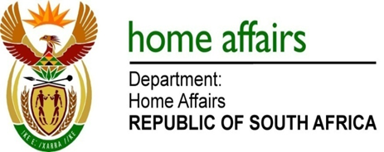

NATIONAL ASSEMBLY

QUESTION FOR WRITTEN REPLY

QUESTION NO. 2627

DATE OF PUBLICATION: FRIDAY, 1 SEPTEMBER 2017

INTERNAL QUESTION PAPER 31 OF 2017

2627. Mr A M Figlan (DA) to ask the Minister of Home Affairs:

What are the relevant details of the measures that the Government will put in place to facilitate the African Union’s vision 2063 of establishing a continental passport for freedom of movement and trade in Africa in contrast to the more strict security measures restricting movement, as proposed by the Border Management Agency? NW2933
REPLY:

The legal instruments relating to the implementation of the aspects of Vision 2063 relating to Free Movement are still being negotiated by the African Union Member States. Upon adoption by the African Union, the Member States will have to sign and, in accordance with their constitutional requirements, ratify and domesticate the legal instruments.
In the case of South Africa, if the legal instruments are ratified and domesticated, all relevant Departments and their entities or agencies will have to implement them as it would be the law in the Republic.

Remarks: Reply: Approved / Not Approved

Mkuseli Apleni Prof. Hlengiwe Mkhize, MP
Director-General Minister of Home Affairs
Date: Date:

