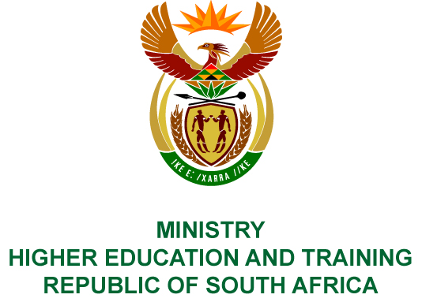
Private Bag X893, Pretoria, 0001, Tel (012) 312 5555, Fax (012) 323 5618
Private Bag X9192, Cape Town, 8000, Tel (021) 469 5150, Fax: (021) 465 7956
Memorandum from the Parliamentary Office
NATIONAL ASSEMBLY
FOR WRITTEN REPLY
QUESTION 2623
DATE OF PUBLICATION OF INTERNAL QUESTION PAPER: 07/09/2018
(INTERNAL QUESTION PAPER NO 29 OF 2018)
Adv A de W Alberts (FF Plus) to ask the Minister of Higher Education and Training:
(1) Whether her department’s language policy on higher education, of which the concept was published in the Government Gazette of 23 February 2018, has already been finalised; if not, (a) which processes are still outstanding and (b) what is the timeframe for finalisation; if so, when will it be published;
(2) whether her department received and considered submissions from (a) the SA Academy for Arts and Science, (b) the Afrikaans Language Board and (c) Afriforum; if not, what is the position in this regard; if so, what are the relevant details in each case;
(3) whether, if the specified policy is not yet finalised, she will possibly consider hosting a symposium in order to refine it; if not, what is the position in this regard; if so, what are the relevant details;
(4) whether she has found that the policy is in compliance with her obligation under subsection 6(4) of the Constitution, 1996, to regulate and monitor the use of official languages by means of legislative and other measures, as subsection 27(2) of the Higher Education Act, Act 101 of 1997, has the aforementioned as its underlying basis;
(5) whether she will make a statement on the matter? NW2910A
REPLY:
- The Department is still in the process of finalising the Language Policy for Higher Education, which was published in February 2018 for public comment.
- The draft was a revision of the 2002 Language Policy for Higher Education. The Department received a large volume of submissions/inputs from various stakeholders, mainly universities and agencies interested in language development in South Africa. The Department has analysed these inputs and is in the process of developing a final draft taking into account the various comments received. The following aspects of the policy are still outstanding:
- Department must submit and request the advice of the Council on Higher Education, as required in terms of the Higher Education Act (Act 101 of 1997); this advice may lead to further policy changes; and
- Socio-Economic Impact Assessment.
- The Department envisages that the final policy will be published by 31 March 2019.
- The Department received submissions from the SA Academy for Arts and Science and AfriForum. No submission was received from the Afrikaans Language Board. All submissions are being considered to ensure that the language policy is consistent with the Constitution and begins to address the historical marginalisation of indigenous African languages. The relevant details of the submissions are as follows:
The SA Academy for Arts and Science welcomed the revised Language Policy for Higher Education and proposed that specific universities be assigned to develop indigenous South African languages. It called for research to be done to establish guiding principles and procedures for the development of new terminology for African languages. Moreover, the Academy suggests that a core cohort of lecturers proficient in African languages be developed to ensure that there are lecturers who can teach in these languages.
Afriforum generally welcomed the review of the policy and called for funding allocations to be made in support of multilingualism at universities. It highlighted the fundamental right of learners/students to receive education in their mother tongue or language of their choice. It supported the proposed partnerships with the Department of Basic Education in promoting the development of all indigenous languages in South Africa. It welcomed the explicit recognition of Afrikaans as an indigenous South African language in the policy.
- The Department has already held a number of symposiums and seminars on this matter and is not planning to hold any others before the policy is finalised. However, the Department will continue to engage with universities and other relevant bodies regarding the implementation of the policy once it is published.
- The revision of the Language Policy for Higher Education is being done in compliance with the Constitution of the Republic of South Africa, 1996 and the Higher Education Act of 1997
(Act 101 of 1997).
- The Minister will communicate to all stakeholders once the policy has been published in the government gazette for implementation.

COMPILER DETAILS
NAME AND SURNAME: MR SIMON MOTLHANKE
CONTACT: 012 312 5260
RECOMMENDATION
It is recommended that the Minister signs Parliamentary Reply 2623.

MR GF QONDE
DIRECTOR–GENERAL: HIGHER EDUCATION AND TRAINING
DATE:

PARLIAMENTARY REPLY 2623 IS APPROVED / NOT APPROVED / AMENDED.
COMMENT/S

MRS GNM PANDOR, MP
MINISTER OF HIGHER EDUCATION AND TRAINING
DATE:

