36/1/4/1(2018)
NATIONAL ASSEMBLY

FOR WRITTEN REPLY

QUESTION 2619

DATE OF PUBLICATION IN INTERNAL QUESTION PAPER: 7 SEPTEMBER 2018 (INTERNAL QUESTION PAPER NO 29-2018)

2619. Mr S P Mhlongo (EFF) to ask the Minister of Police:

- Whether any cases were ever opened regarding the deaths of certain persons (names furnished); if so, (a) what is the status af each (i) case and (ii) investigation, (b) have any suspects been identified and/or arrested in each case and (c) who are the investigating officers in each case;

has there been any indication of police involvement in any of the specified deaths; if so, what are the relevant details?

REPLY:
NW2903E

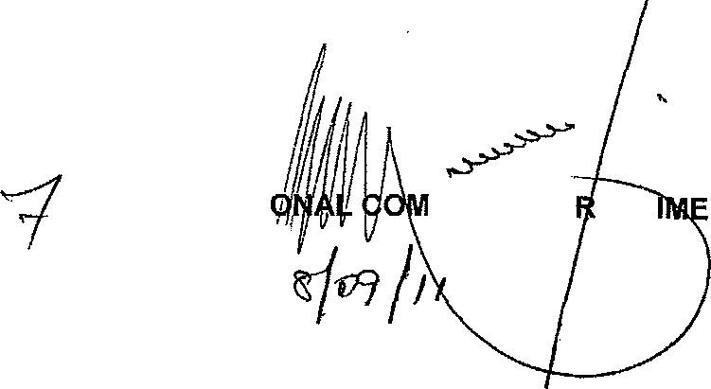
DEPUTY NATI
MISSIONE : CR
Date:

The information that has been provided is insufficient for this office to respond. Additional information, such as case numbers or identity numbers of the persons mentioned is required in order for this office to provide accurate feedback.

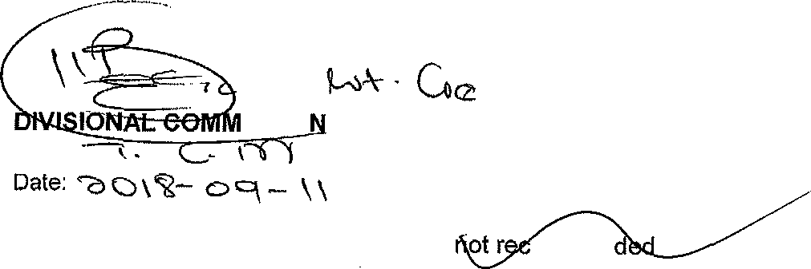
ISSIO ER: DETECTIVE SERVICE
Reply to question 2619 recommended /
ommen

DETECTION

FOR WRITTEN REPLY QUESTION 2619

DATE OF PUBLICATION IN INTERNAL QUESTION PAPER: 7 SEPTEMBER 2018 (INTERNAL QUESTION PAPER NO 29-2018)

Reply to question 2619 recommended /

ER:

Reply to question 2619 approved / red

MINISTER OF POLICE BH CELE, MP
GENERAL H AFRICAN POLICE SERVICE

