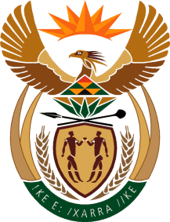

MINISTRY OF TOURISM
REPUBLIC OF SOUTH AFRICA

Private Bag X424, Pretoria, 0001, South Africa. Tel. (+27 12) 444 6780, Fax (+27 12) 444 7027
Private Bag X9154, Cape Town, 8000, South Africa. Tel. (+27 21) 469 5800, Fax: (+27 21) 465 3216

NATIONAL ASSEMBLY:

QUESTION FOR WRITTEN REPLY:
Question Number: 2617
Date of Publication: 6 November 2020
NA IQP Number: 45
Date of reply: 16 DECEMBER 2020

Mr M S F de Freitas (DA) to ask the Minister of Tourism:
With reference to her Budget Vote speech, Vote No 33, on 22 July 2020, what (a) is (i) she and (ii) her department doing to mitigate the gross domestic product contraction and job losses, (b) are her department’s plans in this regard and (c) are the (i) time frames, (ii) timelines and (iii) deadlines in this regard? NW3331E

REPLY:

- (i) and (ii)The Department, working with the sector has followed government’s risk-adjusted strategy for the phased re-opening of economic activities.

- and (c) (i),(ii) and (iii)The associated timelines are contained in the tabled Strategic Plan 2020/21 – 2024/25 as well as the reviewed and retabled Annual Performance Plans 2020/21 – 2022/23.

