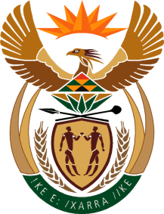

MINISTRY OF TOURISM
REPUBLIC OF SOUTH AFRICA

Private Bag X424, Pretoria, 0001, South Africa. Tel. (+27 12) 444 6780, Fax (+27 12) 444 7027
Private Bag X9154, Cape Town, 8000, South Africa. Tel. (+27 21) 469 5800, Fax: (+27 21) 465 3216

NATIONAL ASSEMBLY:

QUESTION FOR WRITTEN REPLY:
Question Number: 2615
Date of Publication: 6 November2020
NA IQP Number: 45
Date of reply: 05 November 2020

Mr M S F de Freitas (DA) to ask the Minister of Tourism:
With reference to the tourism Toolkits supplied to the Department of International Relations and Cooperation for use by the missions abroad, (a) what do the specified Toolkits comprise, (b) what training linked to the Toolkits is provided and (c) how is the (i) efficiency and (ii) impact of the Toolkits measured?
NW3329E
REPLY:
- What do the specified Toolkits comprise
- Digital marketing collateral including TVC (Brand Videos), Tourism films, images, posters, banners, tourism brochures, maps and destination presentations that are all in our digital asset library
- Press kits, newsletters, digital and social media content to use on their platforms
- Limited hardcopy brochures, maps, USB sticks with digital marketing collateral and promotional items (mostly based on agreed activations and projects)
- Pull-up banners and posters

- What training is linked to the Toolkits is provided.
- Accessing the digital asset library
- Destination Presentation
- Use of the digital and social media content

(c)(i) and (ii) Efficiency and the impact of the toolkits are not measured as a standalone as they are a tool used in a suite of others to achieve broader project or market objectives.

