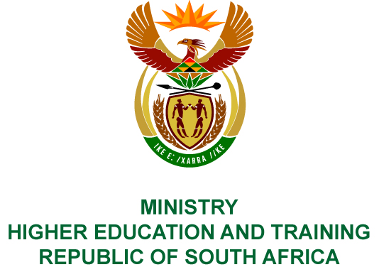
Private Bag X893, Pretoria, 0001, Tel (012) 312 5555, Fax (012) 323 5618
Private Bag X9192, Cape Town, 8000, Tel (021) 469 5150, Fax: (021) 465 7956
Memorandum from the Parliamentary Office
NATIONAL ASSEMBLY
FOR WRITTEN REPLY
QUESTION 2611
DATE OF PUBLICATION OF INTERNAL QUESTION PAPER: 31/08/2018
(INTERNAL QUESTION PAPER NO 28 OF 2018)
Mr L G Mokoena (EFF) to ask the Minister of Higher Education and Training:
(1) Whether she has been informed of (a) the allegations and (b) the case that has been opened against the Chief Executive Officer and members of the board of the National Institute for the Humanities and Social Sciences; if not, what is the position in this regard; if so,
(2) has she instituted an investigation and/or followed up on the allegations and the case; if not, why; if so, what are the relevant details?
NW2905E
REPLY:
- (a) The Minister has received two letters containing allegations of maladministration and corruption against the Chief Executive Officer (CEO) and the Board from NIHSS staff, as well as a whistle-blower.
(b) The Minister has not been made aware of any case opened against the CEO or the Board.
- The Director-General on 20 August 2018 requested the Board of NIHSS to investigate the allegations mentioned above and provide a response to the Department on how they have been addressed. The response was received on 04 September 2018 and is currently being analysed. This response covers the allegations made by the staff and a whistle-blower. The Board has requested the CEO and Human Resource unit to respond to the allegations contained within the formal letter of collective grievance.

