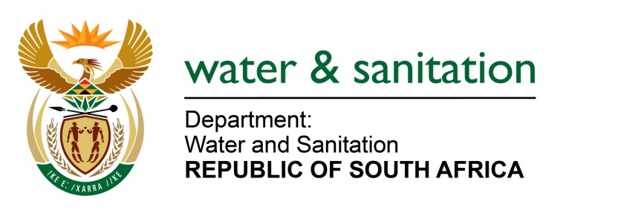

NATIONAL ASSEMBLY

FOR WRITTEN REPLY

QUESTION NO 2611

DATE OF PUBLICATION IN INTERNAL QUESTION PAPER: 18 NOVEMBER 2016
(INTERNAL QUESTION PAPER NO. 38)
2611. Ms T E Baker (DA) to ask the Minister of Water and Sanitation:
With reference to her reply to question 2195 on 31 October 2016, (a) for how many hours has each specified water board sat (i) in the (aa) 2013-14, (bb) 2014-15 and (cc) 2015-16 financial years and (ii) since 1 April 2016 and (b) what is the total amount that each of the specified board members was paid in (i) remuneration and (ii) any other allowances in the specified periods? NW3024E
---00O00---
REPLY:

Requesting the Honourable Member to refer to the Water Boards Annual Reports of each specified financial year.

---00O00---

