National Assembly

Question Number: 2610

Mr K S Mubu (DA) to ask the Minister of Transport:
(a) To what extent have the payments of e-tolls increased since the implementation of the new dispensation announced by the Deputy President, Mr Cyril Ramaphosa, and (b) how do these payments compare to the payments of the 12-month period prior to the announcement of the dispensation? NW2985E
Answer
- The graph below depicts the monthly cash receipts since the announcement of the new dispensation.

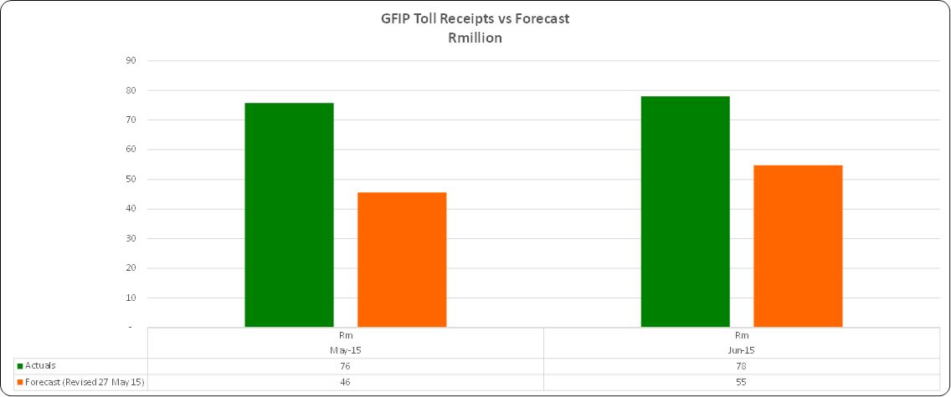

- The graph below depicts the monthly cash flow comparison for the 12 months prior to the announcement of the new dispensation.
