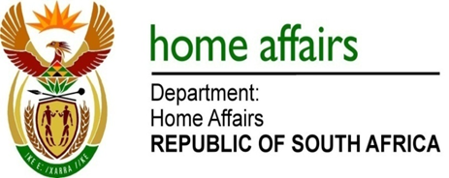

NATIONAL ASSEMBLY

QUESTION FOR WRITTEN REPLY

QUESTION NO. 261

DATE OF PUBLICATION: 15, FRIDAY, FEBRUARY 2019

INTERNAL QUESTION PAPER 2 OF 2019

261. Mrs H O Mkhaliphi (EFF) to ask the Minister of Home Affairs:

What number of (a) tender briefings was held in 2018 by (i) his department and (ii) each of the entities reporting to him and (b) the specified briefings were compulsory? NW272E

REPLY:

The Department and entities responded as follows:

- Department of Home Affairs
- Twenty seven (27) tender briefings were held in 2018 by the Department of Home Affairs.
- Twenty five (25) specified tender briefings were compulsory

- Electoral Commission
- The Electoral Commission held fifty-nine (59) briefing sessions.
- None of these briefing sessions were compulsory.

- Government Printing Works
- Five (5) tender briefings were held.
- Four (4) out of the five (5) tender briefings were compulsory.

Remarks: Reply: Approved / Not Approved

Ms N Mohoboko Dr Siyabonga Cwele, MP
A/Director-General Minister of Home Affairs
Date: Date:

