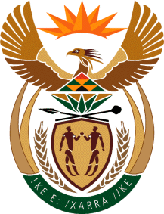
MINISTRY: SPORT AND RECREATION
REPUBLIC OF SOUTH AFRICA

Private Bag X869, Pretoria, 0001, Tel: (012) 304 5158, Fax: (012) 323 8426
Private Bag X9149, Cape Town, 8000, Tel: (021) 465 5506/7/8/9, Fax: (021) 465 4402

Parliamentary Question to the Minister

2609. Mr M S Malatsi (DA) to ask the Minister of Sport and Recreation:
(1) What amount has Boxing SA spent on (a) legal fees and (b) legal counsel in the Xolisani Ndongeni v PBI Operations case to date;
(2) whether a settlement has been reached between all parties involved in the specified case; if not, why not; if so, what are the relevant details? NW3022E
Reply

We are still trying to source information and consulting with the Boxing SA on this matter and the information required is not readily available

