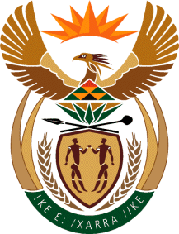
MINISTRY: SPORT AND RECREATION
REPUBLIC OF SOUTH AFRICA

Private Bag X869, Pretoria, 0001, Tel: (012) 304 5158, Fax: (012) 323 8426
Private Bag X9149, Cape Town, 8000, Tel: (021) 465 5506/7/8/9, Fax: (021) 465 4402

Parliamentary Question to the Minister
2608. Mr M S Malatsi (DA) to ask the Minister of Sport and Recreation:
What is the total amount in rands that was spent on (a) him and (b) each member of his delegation on (i) flights, (ii) accommodation and (iii) any further expense for the (aa) 2015 Rugby World Cup in England, United Kingdom, (bb) 2016 Olympic Games and (cc) 2016 Paralympic Games in Rio de Janeiro, Brazil, (dd) Commonwealth Games host announcement in Auckland, New Zealand and (ee) 2015 Cricket World Cup in Australia and New Zealand? NW3021E
Reply

We are still trying to source information from our archives. The Information is not readily available

