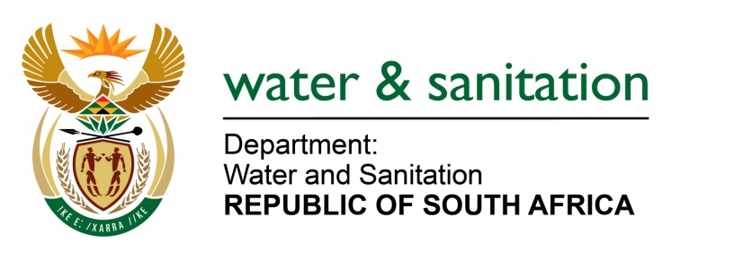

NATIONAL ASSEMBLY

FOR WRITTEN REPLY

QUESTION NO 2603

DATE OF PUBLICATION IN INTERNAL QUESTION PAPER: 24 JULY 2015
(INTERNAL QUESTION PAPER NO. 24)

2603. Mr L J Basson (DA) to ask the Minister of Water and Sanitation:

(1) Why does her department allow sand mining in the riverbed of the Karongwe River in Limpopo which forms part of a protected area under the United Nations Educational, Scientific and Cultural Organisation;

(2) whether she will take any action to stop the sand mining; if not, why not; if so, what are the relevant details? NW2978E
---00O00---
REPLY:
- My Department is not the responsible authority for any mining authorization. We regulate water activities in a water course. The competent authority for granting mining permits is the Department of Mineral Resources.

- A site investigation was conducted on 25 July 2015, by the Department’s enforcement team together with the SAPS. Upon completion of the investigation, my Department will, through its enforcement team, deal with the transgressor appropriately both administratively and criminally.
---00O00---

