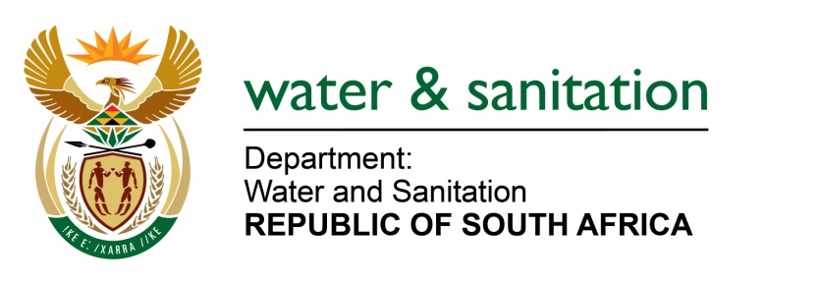

NATIONAL ASSEMBLY

FOR WRITTEN REPLY

QUESTION NO 2602

DATE OF PUBLICATION IN INTERNAL QUESTION PAPER: 24 JULY 2015
(INTERNAL QUESTION PAPER NO. 24)

2602. Mr L J Basson (DA) to ask the Minister of Water and Sanitation:

(1) With reference to her reply to question 1756 on 26 May 2015, has the Water Tribunal started with their work; if not, why not; if so, how many cases have been resolved;

(2) how many cases are outstanding (a) that the previous tribunal did not deal with and (b) in total as at the latest specified date for which information is available? NW2977E
---00O00---
REPLY:
(1) Yes, the Water Tribunal has started with their work. There are no finalized cases. However, the Water Tribunal had its first hearing on the 22 July 2015 to 24 July 2015 and the cases were not finalised and were postponed to 27 August 2015 to 28 August 2015.

(2)(a) As at August 2012 when the Water Tribunal term of office came to an end a total of 124 cases were outstanding.

(2)(b) The Department currently has a total of 313 outstanding cases.

---00O00---

