MINISTRY OF EHERGY
REPUBLIC OF SOUTH AFRICA

PRIVATE BAG x 96, PRETOAI4, QJ01, Tel (012) 406 7658

PRIVATE BAG x 9111, CAPE YOWN, 8000 (021) 469 6412, FaX 1021) 465 5980

National Assembly : 26
Memorandum from the Parliamentary Office

Rease find atact‹ed a response to Parliamentary Question for ›«ritfen reply asked by Mr K J Mileham (DA) to ask f›e Minister of Mineral Resources and Energy.

Mr. loyd Ganta
Acting Deputy Director•General: Governance and Compliance
...-. ....I. 12019
Recommended / Not Recommended
Mr. habane Zulu
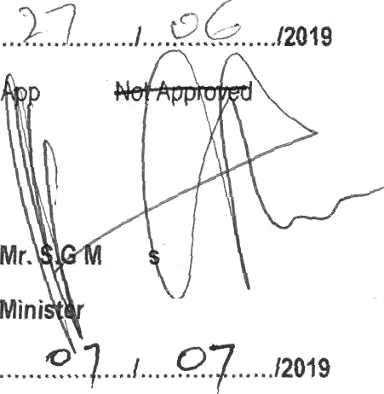
Di›actor General: Department of Energy

rovedl

anta he
of Minefél Resources and Energy

Mr K J Mileham (DA) to ask the Minister of Mineral Resources and Energy:

- Whether, since the reply of the former Minister of Energy to question 556 on 19 March 2019, the forensic report has been finalised; if not, by that date will it be finalised;
- fat is the current actual (a) volume in barrels, (b) average cost in dollars per barrel and (c) valve of the country's strategic fuel reserve;
- what are the details of the Strategic Fuel Fund's current actual policy relating to the rotation of the strategic fuel reserves;
- (a) how often was a rotation of the strategic fuel reserve undertaken in the 2018-19 financial year and
(b) what was the reason actually given for each rotation undertaken in the (i) 2016-17, (ii) 2017-18 and
(iii) 2018-19 financial years? NW983

Reply

  - The Forensic Report has been completed and will 6e tabled before the Board of Directors of CEF for adoption and submission to the Minister.

The assertion of government is that the:
    - volume in barrels is - 10 300 000 barrels of Crude Oil.
    - average cost in dollars per barrel is - $63.99
    - value of the counFy’s strategic fuel reserve currently is - Ma‹tet Value USD 659 Million

  - The Policy on Stock Rotation is being formulated

(a) No stock rotation of strategic fuel reserve was undertaken in 20f8-19 financial year.
(b) (i) For 20\&17, (ii) 2017-18 and (iii) 2018-19 financial year them was no stock rotation.

