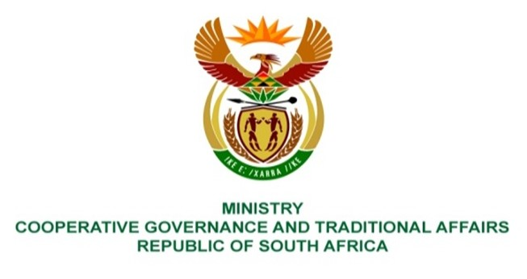

NATIONAL ASSEMBLY
QUESTION FOR WRITTEN REPLY

QUESTION NUMBER 2597
DATE OF PUBLICATION: 26 AUGUST 2022

QUESTION:

2597 Mr D Joseph (DA) to ask the Minister of Cooperative Governance and Traditional Affairs:

- What is the daily allowance that councillors get paid to attend activities of the SA Local Government Association (SALGA) and
- (b) what (i) number of provincial SALGA activities were held for Western Cape municipalities in the 2019-20 financial year, (ii) type of activities took place and (iii) number of councillors attended each activity? NW3113E

REPLY:
- In terms of item 7 of the Notice on upper limits of salaries, allowances and benefits in respect of different members of municipal councils, a councillor designated by the South African Local Government Association (SALGA) to serve in its governance structures is entitled to an allowance not exceeding R1103.23 per day, irrespective of the number of meetings attended by such councillor on a specific day.
(b) (i) According to information obtained from SALGA, fifteen (15) activities and thirty-four (34) meetings were held during the 2019/ 20 financial year, as follows:

No. | (b)(ii)  Types of Activities/ Meetings | (b)(iii)  Number of councillors attended each activity
1 | PEC Meetings | 59
2. | Municipal Finance and Fiscal Policy Working Group | 41
3 | Human Settlements and Municipal Planning Working Group | 40
4. | Community Development and Social Cohesion Working Group | 41
5. | Economic Empowerment and Public Employment Working Group | 35
6. | Environment Planning and Climate Resilience Working Group | 38
7. | Capacity Building and Institutional Resilience Working Group | 43
8. | Water, Sanitation and Waste Management Working Group | 43
9. | Public Transport and Road Working Group | 38
10. | Governance and Inter-Governmental Relations Working Group | 42
11. | Municipal Innovations and Information Technology Working Group | 40
12. | SALGA Women’s Commission Meetings | 81
13. | SALGA Women’s Commission Provincial Lekgotla | 23
14. | Speakers Forum | 56
15. | Provincial Members Assembly | 39

