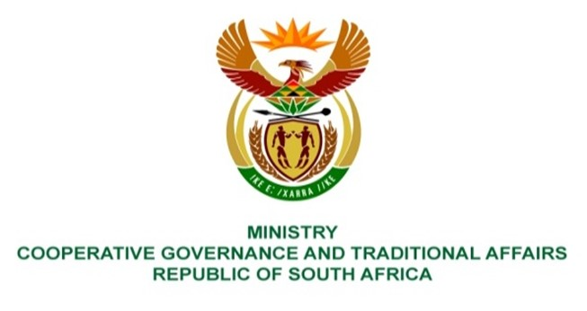

NATIONAL ASSEMBLY
QUESTIONS FOR WRITTEN REPLY

QUESTION NUMBER 2597
DATE OF PUBLICATION: 26 NOVEMBER 2021

QUESTION: PQ 2597
Mrs M O Clarke (DA) to ask the Minister of Cooperative Governance and Traditional Affairs:
(1) What (a) steps has she put in place to deal with the escalating debt owed by Soweto to the City of Johannesburg as little progress has been made in this regard and (b) are the details of a complete plan detailing how the amount will be dealt with;
(2) what is the total debt bill currently reported to her department for defaulting municipalities as the debt bill for the past financial year was R35,5 billion;
(3) in light of the fact that 47 municipalities owed more than 100 million each, what is the (a) name and (b) outstanding amount for each municipality reported to her currently;
(4) what (a) is the total outstanding debt of Soweto reported to her and (b) steps have been taken by her department to assist in recovering the debt? NW3073E
REPLY:
The Honorable member is advised and requested to direct the above Parliamentary Question (PQ2597) to the Minister of Finance as National Treasury is the department in terms of the Municipal Finance Management Act, (MFMA) Section 71 responsible for receiving reports on municipal finance and budget management related aspects. Also the City of Joburg is a non-delegated municipality and reports directly to National Treasury.

