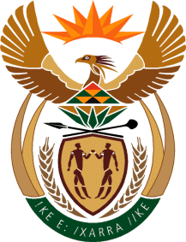

**MINISTRY OF TOURISM**

**REPUBLIC OF SOUTH AFRICA**

Private Bag X424, Pretoria, 0001, South Africa. Tel. (+27 12) 444 6780, Fax (+27 12) 444 7027

Private Bag X9154, Cape Town, 8000, South Africa. Tel. (+27 21) 469 5800, Fax: (+27 21) 465 3216

Ref: TM 2/1/1/10

**NATIONAL ASSEMBLY:**

**QUESTION FOR WRITTEN REPLY:**

**Question Number: 2597**

**Date of Publication: 1 September 2017**

**NA IQP Number: 31**

**Date of reply: 11 September 2017**

**Mr T Rawula (EFF) to ask the Minister of Tourism:**

When are the application dates (a) opening and (b) closing for the board positions of all entities and councils reporting to her? NW2901E

**Reply**

1. Applications for South African Tourism Board positions will open for a period of 30 days in October 2017.

**(b)** Applications for South African Tourism Board positions will close inNovember 2017.