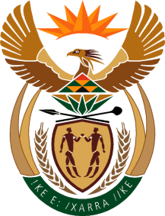

MINISTRY OF TOURISM

REPUBLIC OF SOUTH AFRICA

Private Bag X424, Pretoria, 0001, South Africa. Tel. (+27 12) 444 6780, Fax (+27 12) 444 7027

Private Bag X9154, Cape Town, 8000, South Africa. Tel. (+27 21) 469 5800, Fax: (+27 21) 465 3216

Ref: TM 2/1/1/10

NATIONAL ASSEMBLY:

QUESTION FOR WRITTEN REPLY:
Question Number: 259
Date of Publication: 19 February 2016
NA IQP Number: 2
Date of Reply: 26 February 2016

Ms A Matshobeni (EFF) to ask the Minister of Tourism:
Whether he and/or his department has bought advertising space in The New Age in the (a)2012-13, (b) 2013-14 and (c) 2014-15 financial years; if so, (i) what number of times and (ii) for what amount in each specified financial year?
NW263E

REPLY:

- 2012-13: No
- 2013-14: No
- 2014-15: No

