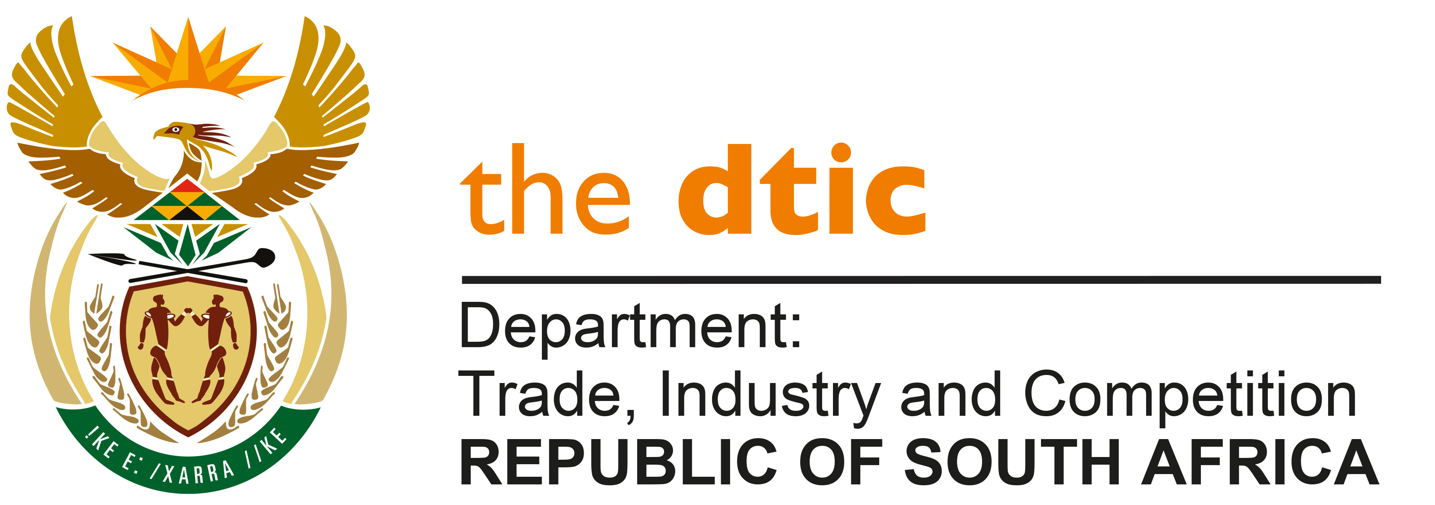

THE NATIONAL ASSEMBLY

QUESTION FOR WRITTEN REPLY

QUESTION NO. 2584

Mr A C Roos (DA) to ask the Minister of Trade, Industry and Competition:
With reference to his reply to question 1293 on 18 November 2019, wherein he indicated that the second phase of the Ekandustria Revitalisation Programme has not been initiated yet pending funding approval, what (a) are the reasons that was no budget set aside in the 2019-20 financial year for the specified programme, (b) further phases and deliverables are planned in the (i) 2020-21 and (ii) 2021-22 financial years, (c) are the budgetary estimates for expenditure in the (i) 2020-21 and (ii) 2021-22 financial years and (d) is the quantum in Rand of funding that has been approved in the 2020-2021 financial year? [NW3255E]

REPLY

I am advised by the Department as follows:

- In the previous reply, the reference to “funding approval” refers to applications from the Mpumalanga Economic Growth Agency/Ekandustria Industrial Park for funding for the second phase, from funds available within the dtic budget. The application for funding for Ekandustria Industrial Park was presented to the dtic Critical Infrastructure programme and referred back on for the Industrial Parks Management - Mpumalanga Growth Agency (MEGA) to provide supporting information on a number of areas including the following:

- A maintenance plan for the industrial park;
- Investment promotion and potential investors pipeline;
- Security measures to be put in place to attend to continuous crime in the industrial park; and
- Progress on restoring the waste-water treatment plant which was revitalised in phase 1 and has since been decommissioned due to crime.

The Critical Infrastructure Programme referred back the Application for Phase 2 for Ekandustria on 3 July 2018, for additional information that was required. the dtic and the DBSA engaged the Mpumalanga Economic Growth Agency MEGA and sent written communication on 27 August, 2018. The revised application has since been received on 10 November, 2020.

The Ekandustria Industrial Park has had significant challenges with several service delivery protests that impacted the revitalization programme, resulting in work stoppages during the first phase and protests continued after the first phase had been completed. The management of MEGA decided to slow down the revitalization process during this time due to the risk that would impact on the assets, the staff of MEGA and the Construction team.

Should the application meet on the necessary requirements it will be presented to the next sitting of the Critical Infrastructure Programme for funding in the fourth quarter.

- Further phases are dependent on the urgent needs of the industrial park and the programme responds to the applications submitted. A guide for the phases is as follows –

Phase 1: Security infrastructure upgrade, fencing, lighting, critical top structures and electrical requirements - The first phase requirements was requested by the industrial parks management agencies who have been experiencing high crime levels.
Phase 2: Compliance to regulatory requirements – Landfill sites; Waste and Water treatment plants, Fire, Health & Safety Requirements, and Renewable energy initiatives.
Phase 3: Engineering designs and construction of new and existing roads, bulk water supply and sewage treatment plants or industrial effluent control.
Phase 4: Upgrading electricity infrastructure, and build new top structures in line with the expansion programme of the Parks.
Phase 5: Development of vacant land and sustainable industrial clusters in the Parks.

(c)&(d) The budgetary estimates for expenditure and the quantum in Rand of funding approved in the 2020-2021 financial year is not available as the dtic has not approved any application for the Ekandustria Industrial Park yet.

-END-

