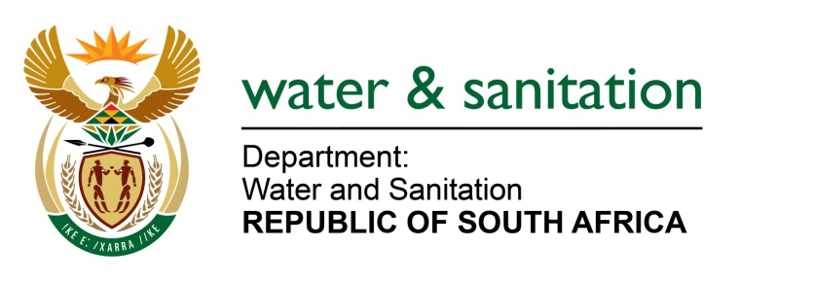

NATIONAL ASSEMBLY

FOR WRITTEN REPLY

QUESTION NO 2583

DATE OF PUBLICATION IN INTERNAL QUESTION PAPER: 26 AUGUST 2022
(INTERNAL QUESTION PAPER NO. 27)

2583. Ms E L Powell (DA) to ask the Minister of Water and Sanitation:

With reference to his reply to question 2954 of 16 December 2020, (a) what is the current status of the National Norms and Standards for Domestic Water and Sanitation Services, (b) what actions must be taken before the Draft Norms and Standards are published for public comment and (c) on what date may the public expect to see and make comments on the Draft Norms and Standards?

NW3098E
---00O00---

MINISTER OF WATER AND SANITATION

- The draft Compulsory National Water and Sanitation Services Norms and Standards has been certified by the State Law Advisor.
- Certification of the initial phase Social Economic Impact Assessment by the Presidency is expected by the end of September, whereafter it will be published for public comment for a period of 60 days.
- Publication of the Norms and Standards for public comments depends on the certification from Presidency, but the target is to publish by 15 October 2022.

---00O00---

