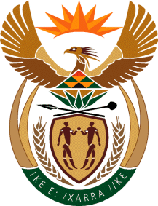
MINISTRY
SPORT AND RECREATION
REPUBLIC OF SOUTH AFRICA

Department of Sport and Recreation l Private Bag X896 l PRETORIA l 0001 l Regent Place l 66 Queen Street l Pretoria l 0001 l +27 (0)12 304 5053 l Fax: +27 (0)12 323 8426
Private Bag X9149 l Cape Town l 8000 l 2nd Floor Parliament Building l 120 Plain Street l CAPE TOWN l Tel: +27 21 469 5705 l Fax: +27 21 465 4402
www.srsa.gov.za
_____________________________________________________________________

NATIONAL ASSEMBLY

WRITTEN REPLY

QUESTION PAPER: No. 31 of 01 SEPTEMBER 2017

DATE OF REPLY: 20 SEPTEMBER 2017

2579. Mr P G Moteka (EFF) asked the Minister of Sport and Recreation:

When are the application dates (a) opening and (b) closing for the board positions of all entities and councils reporting to him? NW2883E

______________________________________________________________________
The Minister of Sport and Recreation
REPLY:

The application dates for Boxing South Africa were as follows:
(a) opened on: 28 July 2017
(b) closed on: 13 August 2017

In the case of the South African Institute for Drug-Free Sport, the advertisement is still to be published, as quotations were awaited from the Government Gazette and the National Press. It is expected that the advertisement will be issued shortly before he end of September 2017 and the closing date for the nominations shall be 30 days from the publication of the advertisement.

