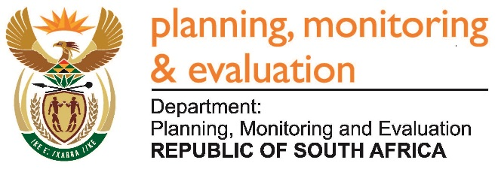
Private Bag X944, PRETORIA, 0001. Union Buildings East Wing, Government Avenue, PRETORIA
Tel: 012 312 0307. www.dpme.gov.za
2575. Ms M O Mokause (EFF) to ask the Minister in the Presidency:
When are the application dates (a) opening and (b) closing for the board positions of all entities and councils reporting to him? NW2879E
REPLY:
The Statistics Council of South Africa was appointed in January 2017 for a period of three years, while the NYDA Board was appointed in May 2017 for a period of five years. Applications will open and close at an appropriate time.

