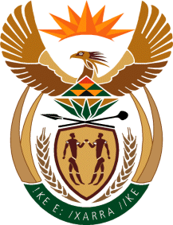

MINISTER IN THE PRESIDENCY: REPUBLIC OF SOUTH AFRICA
Private Bag X1000, Pretoria, 0001, Union Buildings, Government Avenue, PRETORIA
Tel: (012) 300 5200, Website: www.thepresidency.gov.za

NATIONAL ASSEMBLY
WRITTEN QUESTION FOR WRITTEN REPLY

QUESTION NUMBER: 2574
DATE OF PUBLICATIONS: 26 August 2022

2574. Mr H C C Krüger (DA) to ask the Minister in The Presidency: Whether there are any red-tape reduction reforms to the benefit of small, medium and micro enterprises that can be reported by the Red Tape Reduction Unit, given that the specified unit was announced by the President, Mr M C Ramaphosa, more than 120 days ago during the State of the Nation Address on 10 February 2022; if not, (a) why not and (b) by what date can South African taxpayers expect to experience any benefit from the announcement; if so, will he furnish Mr H C C Kruger with a list of the (i) reforms that have been introduced and (ii) expected economic impact thereof? NW3087E

DRAFT REPLY

The Red Tape Reduction initiative led by Mr Sipho Nkosi is working on reducing red tape that impacts investment and business, including small, medium and micro enterprises. In order to be effective, the initiative is focused on working on a limited number of obstacles, and has identified ten priority areas for intervention. This includes initiatives that will benefit SMMEs, namely, faciliting the issuing of tourism transport operating licences, including reducing the backlog in applications; reviewing the regulations hindering informal traders and the township economy; and, identifying obstacles to the growth and operation of the early childhood development sector, the majority of which consists of women-run small businesses.

It is however not possible to quantify the expected economic impact at this stage.

Thank You.

