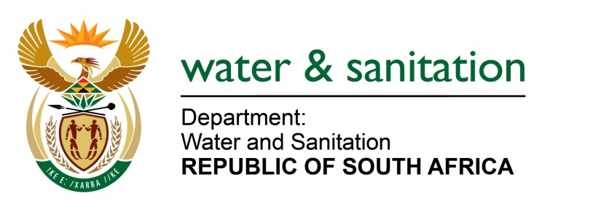

NATIONAL ASSEMBLY

FOR WRITTEN REPLY

QUESTION NO 2562

DATE OF PUBLICATION IN INTERNAL QUESTION PAPER: 18 NOVEMBER 2016
(INTERNAL QUESTION PAPER NO. 38)
2562. Adv A de W Alberts (FF Plus) to ask the Minister of Water and Sanitation:
(1) Whether she is aware of the findings of the report concerning the performance and expense review of the country’s water provisions cycle undertaken by the National Treasury (details furnished); if not, why not; if so,
(2) Whether the findings of the report have led to any new programmes or measures by her department; if not, why not; if so, what are the relevant details;
(3) Whether, in accordance with the review, she has reached the conclusion that approximately 60% of municipal water infrastructure needs to be renewed; if not, why not; if so, (a) what the estimated cost will be to renovate the infrastructure and (b) over what period of time the infrastructure will have to be replaced or renovated;
(4) Whether any steps (a) have been taken or (b) will be taken in this regard to obtain the required funds for the renovation of the infrastructure; if not, why not; if so, what are the relevant details? NW2973E
---00O00---

REPLY:

(1) Yes, I am aware of the findings that are presented in the National Treasury Expenditure and Performance Review (EPR). Please note that the key purpose of the review is to understand the financial implications of water services delivery, not to reflect specifically on sector performance and propose solutions. The Review has also developed an expenditure performance Costing Model that will facilitate regular discussions with National Treasury on the relationship between government expenditure and performance. The model measures (and predicts) performance against current (and future) levels of financial expenditure. The Review confirms what my Department already knows with regards to the current constraints to performance within the water (services) value chain. In fact, my Department provided the consultant with this insight during the initial data and information collection phase, prior to the publication of the Review, but was never given the opportunity to comment on any of the draft versions. The Final Review has not been circulated within my Department for comment.
(2) The findings contained in the Review have not led to any new programme or measures being implemented. My Department, as sector leader and as part of its mandated responsibility, continues to monitor sector performance and intervenes when appropriate, and has recently developed a Regulatory No Drop System in support of Water Conservation and Demand Management, and is finalising a comprehensive and detailed Water Sector Investment Framework, which forms part of an overarching National Water and Sanitation Master Plan.
My Department is also implementing Municipal Water Master Plans within 27 Priority District Municipalities in support of the Water Services Development Planning process, which will ultimately emanate in a pipeline of projects, to address the water services delivery problems that might exist.
(3) Yes, I am aware of the current state of infrastructure in the water sector, and specifically the state of asset management, and associated problems with infrastructure operation and management within municipalities. My Department is busy finalising a detailed municipal investment requirements analysis, which is part of the sector Investment Framework, to confirm the actual extent of the problem, financially, within municipalities. The Investment Framework will be completed in 2017, and my Department will, in due course, make recommendations over what period of time the infrastructure should be replaced, refurbished or extended, while taking into account the current economic environment in the country. The 59% quoted in the Review is based on a preliminary Departmental estimate of infrastructure renewal. Other studies have also based renewal on accumulated depreciation which is only a financial provision for the renewal of infrastructure. This implies that there is shortfall in funding.
(4) Due to this identified shortfall, my Department has engaged with National Treasury and COGTA to establish a new refurbishment fund. The required funds to support the investment requirements have not yet been secured from National Treasury. This will only happen once the Investment Framework has been finalised and the findings and recommendations have been presented and discussed internally within my Department, and once other lead sector departments, who are involved with municipal water services delivery, have had the opportunity to make their inputs. The funding is critical to ensure that the pipeline of projects emanating from the Water Services Master Plans are implemented.
---00O00---

