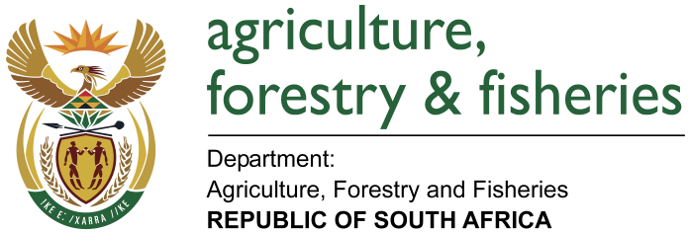
NATIONAL ASSEMBLY

WRITTEN REPLY

QUESTION 2559 / NW 2817E

MINISTER OF AGRICULTURE, FORESTRY AND FISHERIES:
Mr MPG Lekota (COPE) to ask the Minister of Agriculture, Forestry and Fisheries:

QUESTION:

- Whether his department has put any plans in place to address the current drought and water scarcity in the Northern Cape, Western Cape and parts of the Eastern Cape which has detrimental effects on food security and job security; if not, why not; if so, what plans;
- Whether his department is working with any other departments to address and monitor the current situation; if not, why not, if so, (a) is his department part of a national planning initiative and (b) what are the further relevant details? NW2817E
REPLY:
- Yes; the Department has developed a Sectoral Drought Management Plan and its Implementation Guidelines as per Disaster Management Act, 57 of 2002, Disaster Management Amendment Act, 16 of 2015 and the National Disaster Management Framework which addresses drought conditions throughout the Country including the Northern Cape, Western Cape and Eastern Cape.

The Sectoral Drought Management Plan has been developed with the following measures in consideration:

- Establishing integrated institutional capacity and support at all levels of government.
- Increasing awareness and preparedness on impending disasters.
- Establishing and implementing response, recovery and rehabilitation programmes.
- Establishing an effective early warning system and improving information dissemination
- The Department also has measures put in place for post disaster response and recovery including providing support to affected provinces through disaster relief schemes and reprioritisation of funds through programmes such as CASP, Ilima/Letsema among others.

The Department also developed the National Drought Action/Response Plan which looks at the short to long term interventions as well as the Drought Indicator Guidelines.

- Yes; the Department is working with other relevant departments such as:
Department of Cooperative Governance and Traditional Affairs (CoGTA), Department of Water and Sanitation (DWS), Department of Rural Development and Land Reform (DRDLR) as well as academic and research institutions such as Universities, Council for Scientific and Industrial Research (CSIR) and Agricultural Research Council (ARC) among others.

- The Department participates in National Joint Drought Coordinating Committee, Inter-Ministerial Task Team on Drought and also chairs the National Drought Task Team.

- The Department is working with provinces to promote awareness on drought coping strategies and capacity building. Farmers are also being advised continuously to follow good farming practices to minimize the impact of drought and to conserve natural resources. Provinces are also putting measures in place to address the situation; Northern Cape is currently assisting with transportation to deliver maize to critical areas: 800 ton already delivered to Upington, Springbok, Pofadder, Williston, Calvinia and Loeriesfontein where about 1300 Farmers have already been assisted and assistance is still ongoing.

Western Cape Province has been allocated an amount of R40 million for purchasing and distribution of animal feed for which implementation will soon commence.

The Eastern Cape Province has declared local state of drought disaster in Amathole, Sarah Baartman District Municipalities and Nelson Mandela Metro in terms of section 55 (1) of the Disaster Management Act (Act No. 57 of 2002). The classification process is due to be finalized by the National Disaster Management Centre. The Department will provide all necessary support to the Province to ensure that drought impacts are mitigated.

