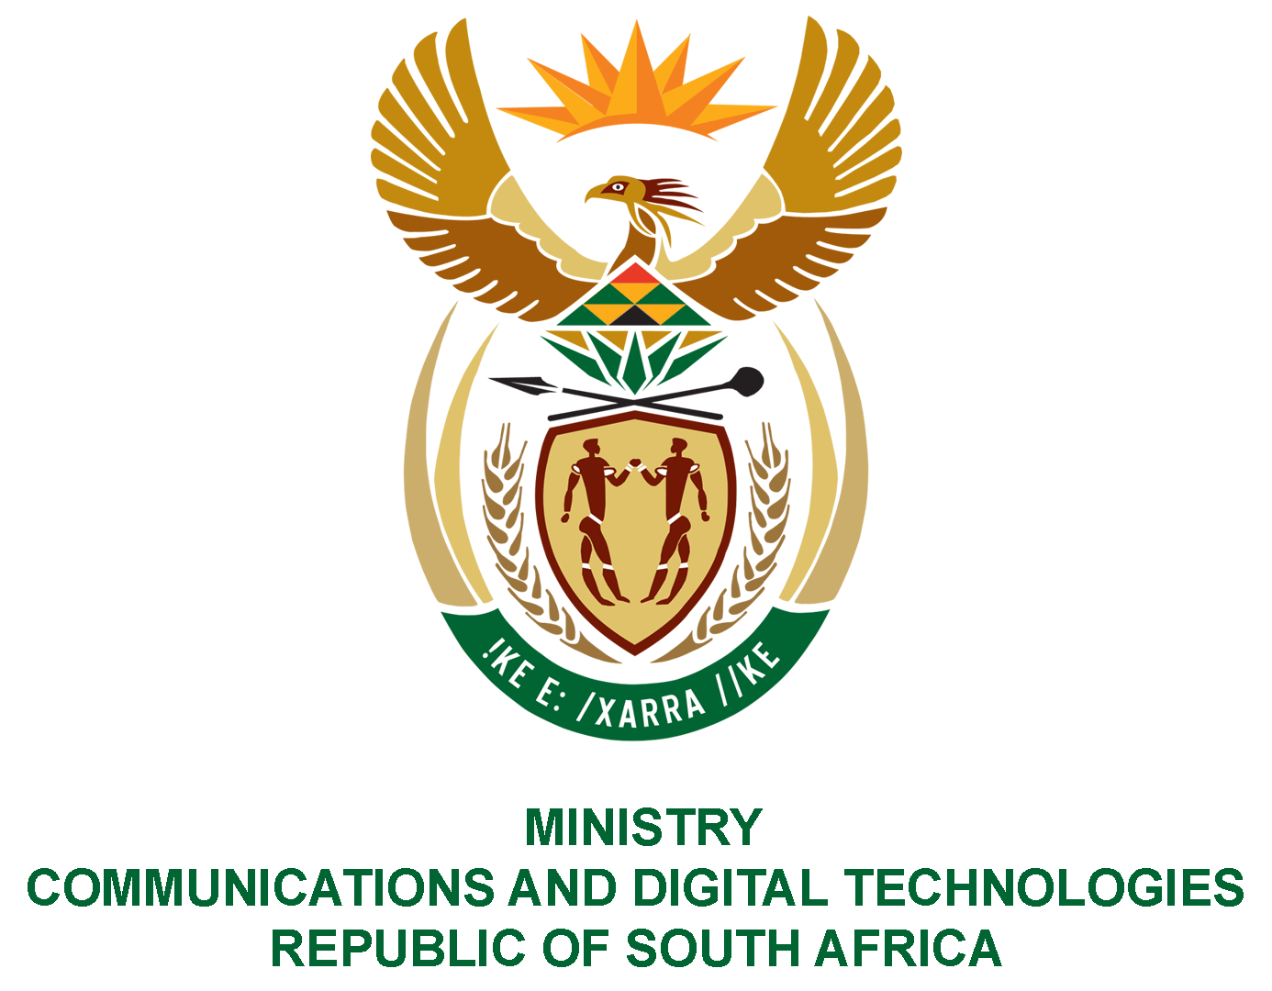
PARLIAMENT OF THE REPUBLIC OF SOUTH AFRICA
NATIONAL ASSEMBLY
WRITTEN REPLY
QUESTION NO: 2547
DATE OF PUBLICATION: 30 October 2020
QUESTION PAPER NO: 42

Ms P T van Damme (DA) to ask the Minister of Communications:

Whether her department awarded any tenders to any non-South African companies (a) in the past three financial years and (b) since 1 April 2020; if not, what is the position in this regard; if so, what (a) is the name of each business to whom the tender was awarded, (b) is the name of the country where each company is based, (c) is the amount of each tender that was awarded to each specified company and (d) was the service and/or product that was supplied by each business?
NW3218E
REPLY:

I was advised by the department as follows:

- (a) No, there were no tenders awarded in the past three financial years.

(b) No. No tenders were awarded to any non-South African companies since 1
April 2020.

(c) Not applicable.

(d) Not applicable.

MS. STELLA NDABENI-ABRAHAMS, MP
MINISTER OF COMMUNICATIONS AND DIGITAL TECHNOLOGIES

