36/1/4/1(201800241)
NATIONAL ASSEMBLY

FOR WRITTEN REPLY

QUESTION 2546

DATE OF PUBLICATION IN INTERNAL QUESTION PAPER: 31 AUGUST 2018 (INTERNAL QUESTION PAPER NO 28-2018)

2546. Mr M Waters (DA) to ask the Minister of Police:

- Whether, with reference to his reply to question 1778 on 18 June 2018, and in view of the fact that the Bedfordview Police Station has four sectors, he has found that the optimal number of visible police officers should actually be 64, in correlation with four members per shift per sector for four shifts; if not, how can the specified police station be expected to fulfil its requirement of two sector vehicles patrolling each sector at all times;

- given the inevitability of police officers taking leave, including but not limited to family responsibility leave, sick leave, study leave and annual leave, what number of additional visible police officers should the police station have in order to ensure that two vehicles per sector are patrolling at all times?
NW2835E
REPLY:

- The Bedfordview Police Station is currently unable to fulfil the requirement of two vehicles per sector, due to a shortage of resources.

- The Bedfordview Police Station has three sectors, with two members per sector, per shift and one vehicle, per shift, implying a total of 24 members. In order to fulfil the requirement of two vehicles per sector, an additional 32 members are required.

Original signed LIEUTENANT GENERAL PROVINCIAL COMMISSIONER: GAUTENG DS DE LANGE

Date: 6 September 2018

2

Reply to question 2546 recommended/

CO
KJ LE (SOEG)

GENERAL
NE UTH AFRICAN POLICE SERVICE

Reply to question 2546 approved/ p oved

MINIS OF POLICE
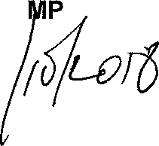
BH CELE,

Date: @/

FOR WRITTEN REPLY QUESTION 1778

NATIONAL ASSEMBLY
36/1/4/1(201800183)

DATE OF PUBLICATION IN INTERNAL QUESTION PAPER: 1 JUNE 2018 (INTERNAL QUESTION PAPER NO 19-2018)

1778. Mr M Watera (DA) to ask the Minister of Police:

  - What is the current (a) actual and (b) optimal number of police officers involved with sector policing at the Bedfordview Police Station;

  - by what date will the specified police station receive Its full complement of sector police officers?
NW1935E
REPLY:

(1)(a)(b) and (2)
(1)(a)  Actual  24 | (1)(b)  Optimal (Ideal) | (2)  Date when full complement will  be reached
 | ” ”  23 (+1) | During the 2017/2018 financial year, one student was allocated to the police station.

Police Station

Bedfordview Sector Policing

Reply to question 1778 recommended/

GENERAL AFRICAN POLICE SERVICE

Date§§]g .g§- § 8
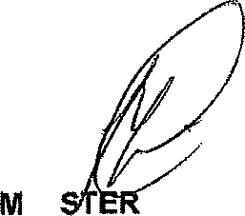
Repl}1o question 1778 approved/n

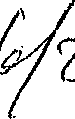
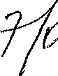
INI OF POLICE BH CELE, MP

