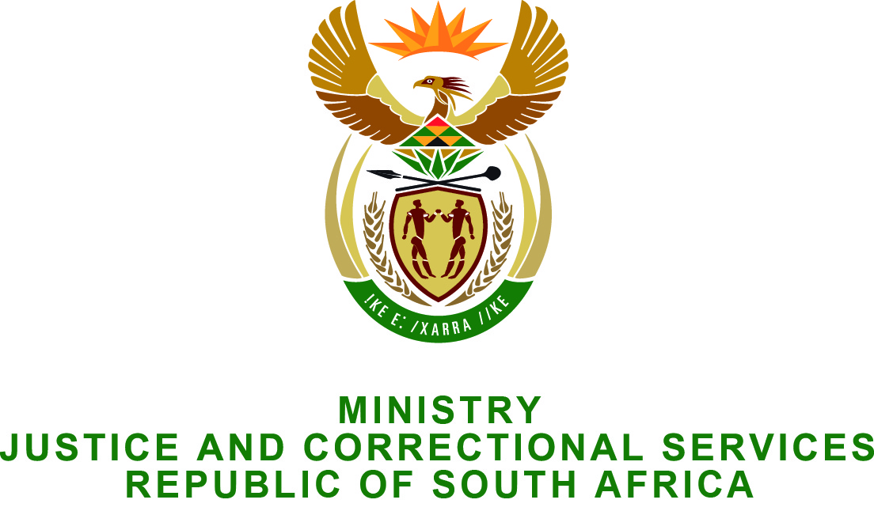

PARLIAMENT OF THE REPUBLIC OF SOUTH AFRICA
NATIONAL ASSEMBLY

FOR WRITTEN REPLY

QUESTION NO: 2545

Prof C T Msimang (IFP) to ask the Minister of Justice and Correctional Services:

With reference to the perceived inconsistency in the manner in which the Department of Correctional Services is handling medical parole applications, (a) how many applications for parole were received in the 2013-14 financial year, (b) how many of the specified applications were successful and (c) how many of the applicants whose applications were not successful died in incarceration? NW2917E

REPLY:
- One hundred and twelve (112) applications for medical parole were received in the 2013-2014 financial year.
- Thirty eight (38) applications were recommended by the Medical Parole Advisory Board (MPAB) and out of this thirty seven (37) were successfully released. One (01) not released due to lack of family support.
- Fifty nine (59) applications were not recommended by the MPAB for medical parole as they did not meet criteria for release. None of these applicants died whilst incarcerated.

For the remaining fifteen (15):
- Seven (7) died before they could be examined by the Medical Parole Advisory Board (MPAB):
- One (1) died whilst awaiting further medical examination and
- Seven (7) are awaiting further review by the MPAB.

