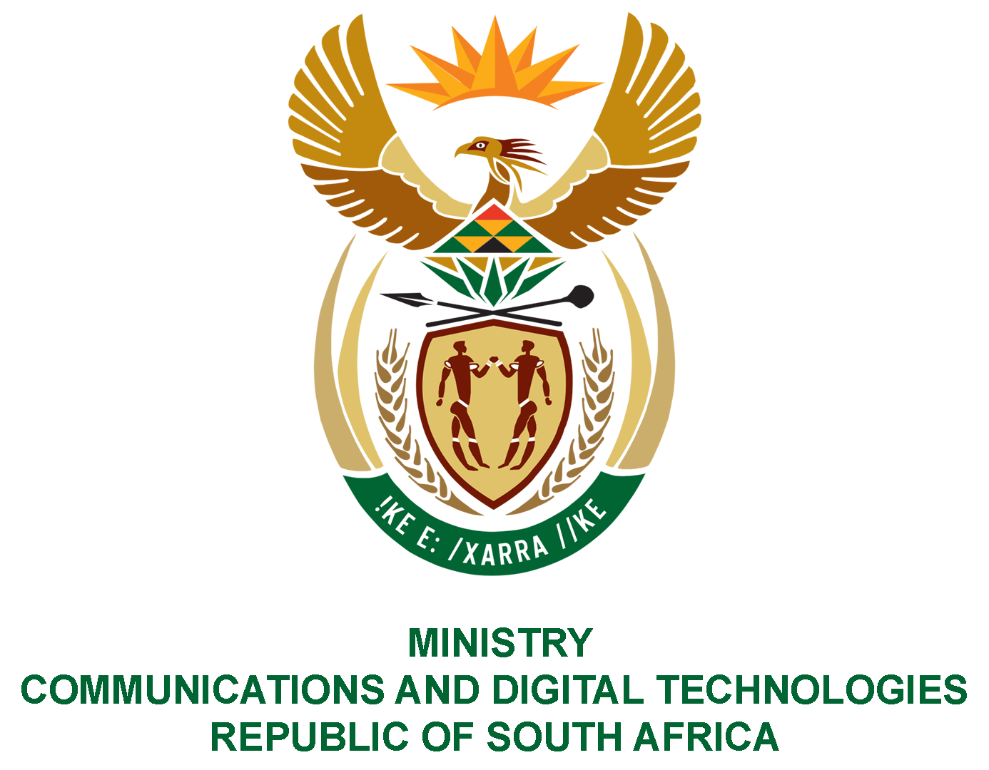
PARLIAMENT OF THE REPUBLIC OF SOUTH AFRICA
NATIONAL ASSEMBLY
WRITTEN REPLY

QUESTION NO: 2544
DATE OF PUBLICATION: 30 October 2020
QUESTION PAPER NO: 42
Mrs M O Clarke (DA) to ask the Minister of Communications:
With reference to the announcement made by the President, Mr M C Ramaphosa, on 9 April 2019 of a 30-member Presidential Fourth Industrial Revolution Commission to provide the Republic with a digital transformation strategy plan, (a) what are the names of the current members of the specified commission, (b) what are the reasons that the commission only present the plan to the President in August 2020 and (c) on what date will her department be presented with the commission’s report? NW3215E

REPLY:

I have been advised as follows:
- Names of current members of the Presidential Commission on the Fourth Industrial Revolution:

- Prof. Tshilidzi Marwala
- Prof. Chris Adendorff
- Ms Beth Arendse
- Mr Mpho Dagada
- Mr Thulani Dlamini
- Mr Abdul Esakjee
- Dr Bernard Fanaroff
- Dr Micheal Gastrow
- Mr Xolile George
- Ms Chairmaine Houvet
- Dr Prince Jaca
- Mr Tervern Jaftha
- Mr Shameel Joosub
- Ms Nomso Kana
- Ms Marinda Kellerman (resigned)
- Mr Baxolile Mabinya
- Mr Rendani Mamphiswana
- Ms Lindiwe Matlali
- Ms Busisiwe Mbuyisa
- Ms Nomvula Mkhonza
- Mr Vukani Mngxati
- Mr Joseph Ndaba
- Dr Nompumelelo Happworth-Obokoh
- Mr Rendani Ramabulana
- Dr Leon Rolls
- Mr Rob Shuter
- Dr Sibongiseni Thotsejane
- Mr Aubrey Tsabalala
- Mr Gerhard van Deventer
- Mr Ben Venter
- Ms S’onqoba Vuba
- Mr Andile Ngcaba

- The advent of the COVID-19 in March 2020 prompted that the planned presentation to the President in March 2020 be postponed accommodating the availability of the President. The confirmed date for presentation to the President was 06 August 2020. The diagnostic report was also presented to the President on 07 November 2019.

- The report was presented to the department on 21 January 2020.

MS. STELLA NDABENI-ABRAHAMS, MP
MINISTER OF COMMUNICATIONS AND DIGITAL TECHNOLOGIES

