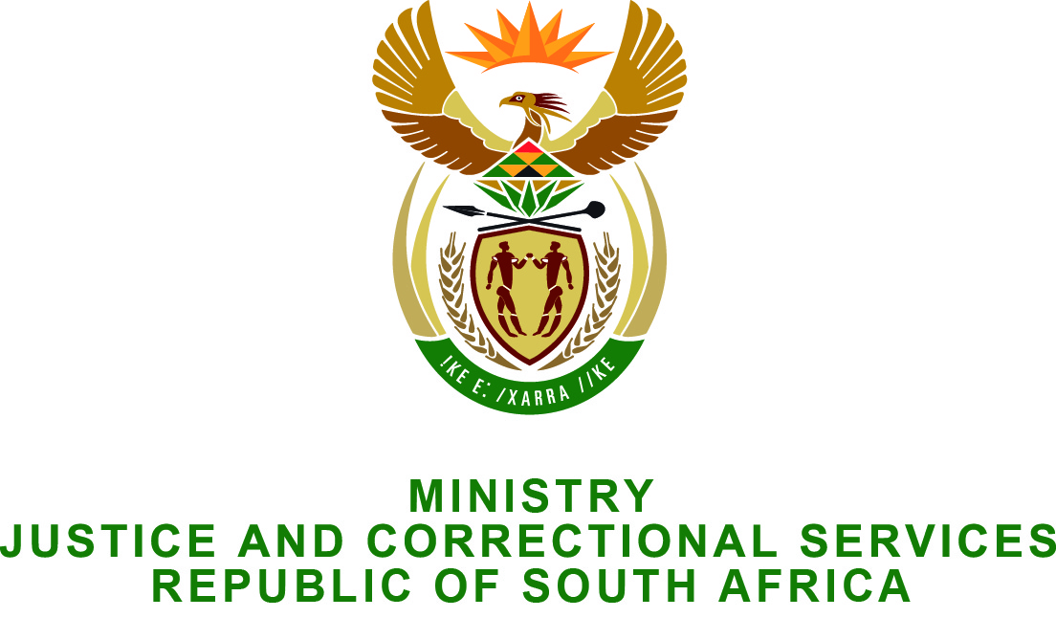

NATIONAL ASSEMBLY
QUESTION FOR WRITTEN REPLY
PARLIAMENTARY QUESTION NO.: 2543
DATE OF QUESTION: 26 JUNE 2015
DATE OF REPLY: 10 JUNE 2015

Adv A de W Alberts (FF Plus) to ask the Minister of Justice and Correctional Services:†

With reference to his reply to question 1705 on 26 May 2015 and to question 1485 on 30 April 2015, when does he intend to finalise the (a) investigation into the actions of the Midvaal Local Authority, (b) report of the Special Investigative Unit regarding the specified local authority, (c) signing off of the specified report by the President and (d) steps to be taken against any institutions or persons identified in the specified report? NW2915E

REPLY:
The SIU Report is still in process of legal review by the SIU. The reason for this process taking so long is that the lead investigator passed away. As a result a new investigator had to be assigned to re-engage the whistleblowers to clarify certain aspects of the investigation.

