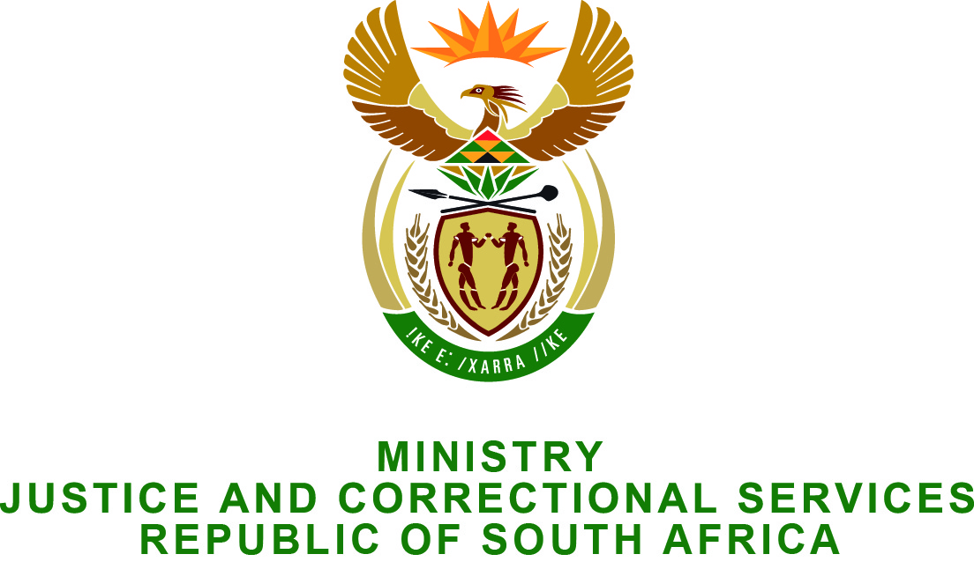

NATIONAL ASSEMBLY
QUESTION FOR WRITTEN REPLY
PARLIAMENTARY QUESTION NO.: 2542
DATE OF QUESTION: 26 JUNE 2015
DATE OF REPLY: 10 JULY 2015

Adv A de W Alberts (FF Plus) to ask the Minister of Justice and Correctional Services:†

(1) Whether any unit attached to the (a) SA Police Service (SAPS) or (b) SA Revenue Service (Sars) has investigated the amounts which (i) a certain person (name furnished) and (ii) two officials of the Local Action Committee (LAC) for Fifa’s 2010 Soccer World Cup Tournament received from (aa) Fifa, (bb) the Government or (cc) any other person/s associated with Fifa, which were allegedly not declared by them and on which no tax was paid; if so, (aaa) when was the investigation undertaken, (bbb) who led the investigation, (ccc) when was the investigation finalised and (ddd) whether a recommendation was made to prosecute a person or persons in this regard;

(2) whether, consequential to the specified investigation, a certain person (name and details furnished) from the Special Revenue Unit of the National Prosecuting Authority decided to prosecute a person or persons; if not, who took the decision to institute prosecutions;

(3) whether (a) steps were taken to prosecute a person or persons and (b) the prosecution was carried out; if not, why not; if so, what was the outcome of this case;

(4) Whether he will investigate such claims? NW2914E

REPLY:
The Minister wishes to inform the Honorable member as follows:
- Questions regarding investigations by the South African Police Service and the SA Revenue Service should be submitted to the Minister of Police and the Minister of Finance, respectively, as it does not fall within the line function of my Ministry.

- I have been informed that the National Prosecuting Authority is not aware of such a matter being referred to the prosecutor.

- Falls away.
- Yes. If more substantiated can be provided.

