FOR WRITTEN REPLY QUESTION 2539

NATIONAL ASSEMBLY
36/1/4/1(2018)

DATE OF PUBLICATION IN INTERNAL QUESTION PAPER: 31 AUGUST 2018 (INTERNAL QUESTION PAPER NO 28-2018)

2539. Mr S J F Marais (DA) to ask the Minister of Police:

- With reference to two cases, CAS 259/10/2015 and 261/10/2015, registered at the Worcester Police Station, (a) what are the reasons that the two cases are delayed and not sent to the State prosecutor at the Worcester Magistrate Court,
(b) why was the Western Cape Police Ombudsman not able to conclude on the cases subsequent to them being referred to him and (c) what is the usual time frame for such cases to be concluded and referred to the prosecuting authorities;

- whether he has found that the delay is intentional; if not, why has there been a time delay of three years; if so, (a) what steps will his department take to speed up the investigations and (b) what consequences will the officials who are not dealing with the cases promptly suffer?
NW2826E
REPLY:

(1)(a) The two (2) case dockets (Worcester CAS 259/10/2015 and 261/10/2015) were submitted to the Senior Public Prosecutor on several occasions and received back with guidance on further investigations to be conducted. The last date that the case dockets were received back was on 5 September 2018 and the Investigating Officer is busy dealing with instructions issued by the Senior Public Prosecutor.

(1)(b) The Ombudsman on Policing in the Western Cape reports to the Provincial Government and not to the South African Police Service. This office can therefore not respond to this question.

(1)(c) The complexity of these cases vastly differ from one to the other and therefore a standard acceptable timeframe cannot be determined.

(2) This office has found that the delay is not intentional. The case was nolle prosequi and was only re-opened by the police after the complainant approached the NPA seeking clarity.

(2)(a) Not applicable.

(2)(b) Not applicable. ›

DI
TC

Date:
LIEUTENANT GENERAL MISSIONER: DETECTIVE SERVICE

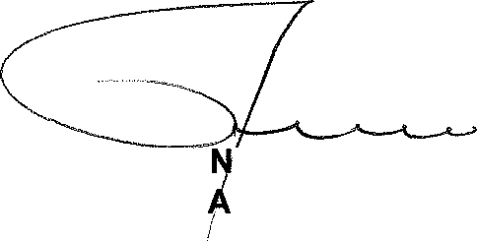
FOR WRITTEN REPLY

QUESTION 2539

DATE OF PUBLICATION IN INTERNAL QUESTION PAPER: 31 AUGUST 2018 (INTERNAL QUESTION PAPER NO 28-2018)
(INTERNAL QUESTION PAPER NO 28-2018)

Reply to question 2539 recommended / the

LIEUTENANT GENERAL DEPUTY ATIONAL COMMISSIONER: CRIME DETECTION LJ TSUM NE

Reply to question 2539 recommended /

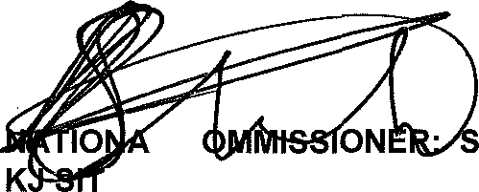
GENERAL OUTH AFRICAN POLICE SERVICE

L C
OLE (SOEG)

Reply to question 2539 approved /

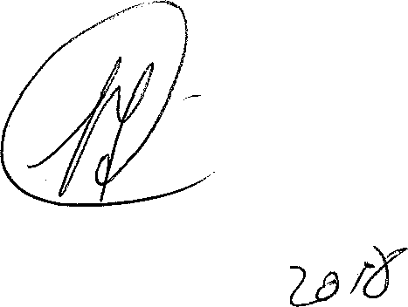
MINISTER OF +! ** BH CELE, MP

