MINISTRY: COMMUNICATIONS
REPUBLIC OF SOUTH AFRICA
Private Bag X 745, Pretoria, 0001, Tel: +27 12 473 0164 Fax: +27 12 473 0585
Tshedimosetso House,1035 Francis Baard Street, Tshedimosetso House, Pretoria, 1000

NATIONAL ASSEMBLY
QUESTION FOR WRITTEN REPLY
QUESTION NUMBER: 2537
DATE OF PUBLICATION: 11 NOVEMBER 2016

Ms P T van Damme (DA) to ask the Minister of Communications:

What were the monthly (a) listenership and (b) advertising revenue figures for each SA Broadcasting Corporation radio station since 12 May 2016? NW2951E

REPLY: MINISTER OF COMMUNICATIONS

- Radio audiences are measured quarterly and not monthly. There was a significant change in radio audience research methodology during the period in question (from previous SAARF RAMS to BRC RAM) and the findings are thus not comparable. The following graphic was derived from the first BRC RAM research released in August 2016.
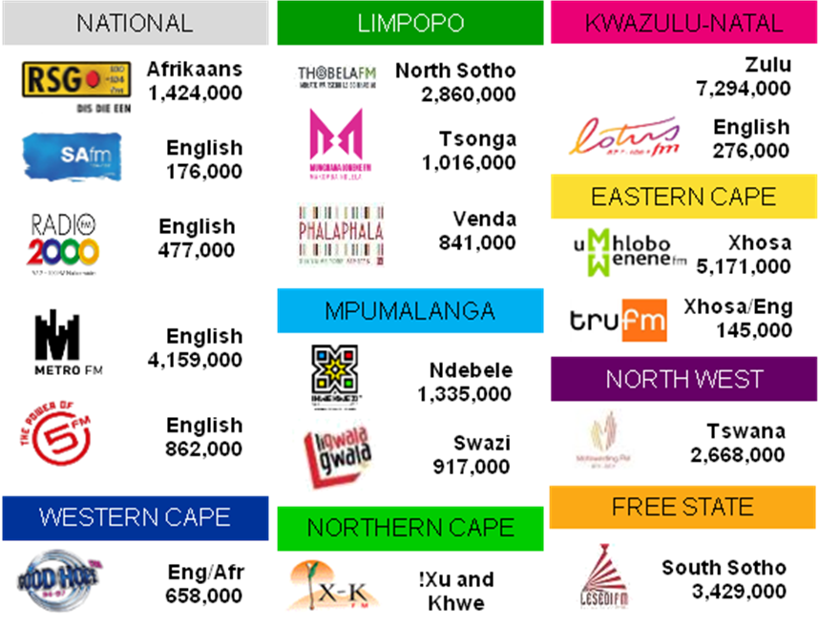

(b) Advertising revenues are presented excluding Agency Commission, Credit Notes, and Compensation. The revenues received by the organisation fluctuate according to available spend by advertisers.

MR NN MUNZHELELE
DIRECTOR GENERAL [ACTING]
DEPARTMENT OF COMMUNICATIONS
DATE:

MS AF MUTHAMBI (MP)
MINISTER OF COMMUNICATIONS
DATE

