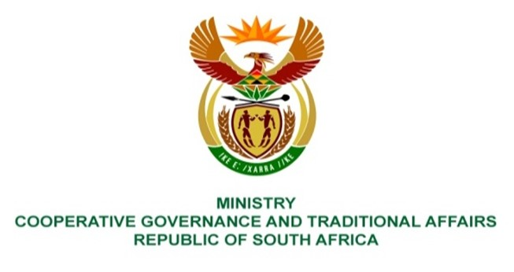

NATIONAL ASSEMBLY
QUESTION FOR WRITTEN REPLY

QUESTION NUMBER 2536
DATE OF PUBLICATION: 26 AUGUST 2022

QUESTION:

- Mr K Ceza (EFF) to ask the Minister of Cooperative Governance and Traditional Affairs:
What measures have been put in place to protect municipal employees who are witnesses on municipal corruption cases, which have come to light through the section 106 Municipal Systems Act investigations? NW3037E

REPLY:
The information requested by the Honourable Member is not within the perview of the Department Coorperative Governance and Traditional Affairs but that of Police. It is recommended that the question be transferred to Ministry of Police.

