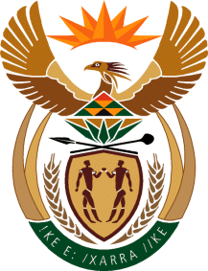

MINISTRY OF TOURISM
REPUBLIC OF SOUTH AFRICA

Private Bag X424, Pretoria, 0001, South Africa. Tel. (+27 12) 444 6780, Fax (+27 12) 444 7027
Private Bag X9154, Cape Town, 8000, South Africa. Tel. (+27 21) 469 5800, Fax: (+27 21) 465 3216

NATIONAL ASSEMBLY:

QUESTION FOR WRITTEN REPLY:
Question Number: 2526
Date of Publication: 30 October 2020
NA IQP Number: 42
Date of reply: 16 December 2020

Mr K P Sithole (IFP) to ask the Minister of Tourism:
Whether there are any plans to invest in tourism subsidies to encourage domestic demand as some of the industry’s biggest market countries have been categorised as high risk and therefore banned from leisure travel into the Republic; if not, what contingency plans are in place, beyond the already distributed relief fund, to support the industry in the event of a second wave of Covid-19 infections; if so, (a) what is the budget allocation for the subsidies and (b) will she furnish Mr K P Sithole with the (i) details of how subsidies will be allocated and (ii) criteria for selecting successful applicants? NW3196E
REPLY:

(a)-(b) (i) and (ii)
There is neither a policy decision nor a plan to subsidise domestic travel, however engagements with the sector aimed to encourage responsible pricing that would stimulate increase in domestic leisure travel. There is also no additional financial relief measure specific to the sector at this stage owing to the constraints in the fiscal environment. However, tourism businesses are encouraged to make use of the R200 billion credit guarantee scheme/facility that was setup between the Reserve Bank, commercial banks and the National Treasury.

