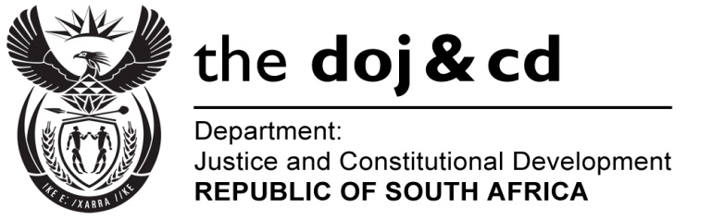
NATIONAL ASSEMBLY
QUESTION FOR WRITTEN REPLY
PARLIAMENTARY QUESTION: NO. 2519
DATE OF QUESTION: 11 NOVEMBER 2016

DATE OF SUBMISSION: 25 NOVEMBER 2016
Mr W Horn (DA) to ask the Minister of Justice and Correctional Services:
(a) How many cases relating to the contravention of the Public Finance Management Act, Act 1 of 1999, as amended, is the National Prosecuting Authority currently prosecuting and (b) what is the quantum of each of the specified prosecutions?
NW2933E
REPLY:

The National Prosecuting Authority (NPA) has informed me that the NPA does not collate specific statistics on offence. However, the table below highlights cases that are extracted from the case administration system developed by SCCU Regional Heads.

Particulars of the Matter | Quantum/Amount Involved
- The State v Legodi Boshielo & 2 others – Project Mobile Classrooms - Department of Education - Limpopo | R70 million
- The State v Mogotlane and Nemavhola- Project Mankele Bridge - Department of Roads and Transport - Limpopo | R79,5 million
- The State v Mweli and Others- Project Department of Education - North West | R16 million
- The State v Sbu Ndebele and Others - Project Tasima - Department of Transport - Pretoria | R42.5 million
- The State v Savoy and Others- Project Intaka- Department of Health - KZN | R70 million
- The State v .Energy Utility Services (Pty) Lt and Others – Project Eskom – Western Cape | R65 million
- The State v Steven Jonkers and Another- Project Bus Contractor - Department of Transport - Northern Cape | R14,5 million
- The State v Scholtz and Others - Project Trifecta - Department of Social Development - Northern Cape | R200 million

