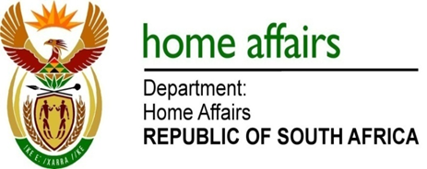

NATIONAL ASSEMBLY

QUESTION FOR WRITTEN REPLY

QUESTION NO. 2519

DATE OF PUBLICATION: Friday, 26 June 2015

INTERNAL QUESTION PAPER 23 OF 2015

2519. Mr J Vos (DA) to ask the Minister of Home Affairs:
(1) With reference to the inter-ministerial task team to be formed to consider the so-called unintended consequences of the new visa regulations on the tourism industry, (a) by what date will the specified team be formed, (b) what is the exact mandate of the team, (c) what (i) are the names and (ii) is the designation of each member of the team and (d) what is the team empowered to do;
(2) will a composite finding be made; if so, by when? NW2890E
REPLY:
(1)(a) The date of the Inter-Ministerial Task Team is currently being processed by the Deputy Presidency which is facilitating the meeting.
(1)(b) The mandate of the team, as prescribed by Cabinet, is to propose measures to mitigate potential unintended consequences that occur as a result of administrative challenges.
(1)(c)(i)-(ii) The team is constituted by Ministers as announced by the President drawn from the Social, Economic and Security Clusters.
(1)(d) The team is empowered to deliver on its mandate as per (b) above.
- Refer to 1(d) above.

