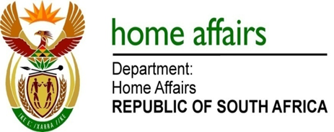

NATIONAL ASSEMBLY

QUESTION FOR WRITTEN REPLY

QUESTION NO. 2517

DATE OF PUBLICATION: Friday, 11 November 2016

INTERNAL QUESTION PAPER 37 OF 2016

2517. Mr D W Macpherson (DA) to ask the Minister of Home Affairs:

Whether, with reference to his replies to questions (a) 2140 and (b) 2141 on 28 October 2016, any South African embassy and/or consulate in the Russian Federation issued a visa to any of the specified Russian nationals; if so, what are the relevant details in each case in terms of the (i) type, (ii) duration of stay and (iii) dates of validity of each of the specified visas? NW2931E
REPLY:

The Honourable Member is requested to provide me with details such as passport numbers and other additional information to enable me to validate the information on our systems and provide a response.

