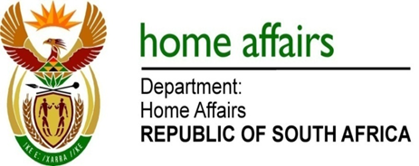

NATIONAL ASSEMBLY

QUESTION FOR WRITTEN REPLY

QUESTION NO. 2516

DATE OF PUBLICATION: FRIDAY, 31 AUGUST 2018

INTERNAL QUESTION PAPER 28 OF 2018

2516. Mr M H Hoosen (DA) to ask the Minister of Home Affairs:

What amount did (a) his department and (b) each entity reporting to him spend on (i) advertising and/or (ii) communication services on the (aa) Africa News Network 7, now known as Afro Worldview and (bb) New Age newspaper, now known as Afro Voice, (aaa) in the (aaaa) 2016-17 and (bbbb) 2017-18 financial years and (bbb) since 1 April 2018? NW2803E
REPLY:

- Department of Home Affairs

(i)(aa) R0
(i)(bb)(aaaa) R50,944.32 on advertising in support of the 2016/17 Mkhaya Migrants Awards Call for Nominations Media Campaign.
(i)(bb)(bbbb) Not Applicable
(i)(b)(bb) Not applicable

(ii)(aa-bb) R0 spent for communication services in (aaaa), (bbbb) and (bbb).

- Electoral Commission

The Electoral Commission has not spent any moneys on (i) advertising and/or (ii) communication services on the Africa News Africa News Network 7, now known as Afro Worldview and (bb) New Age newspaper, now known as Afro Voice, (aaa) in the (aaaa) 2016-17 and (bbbb) 2017-18 financial years and (bbb) since 1 April 2018.

- Government Printing Works

- None
- None
(aa) None
(bb) None
(aaa) None
(aaaa) Not applicable
(bbbb) Not applicable
(bbb) Not applicable

