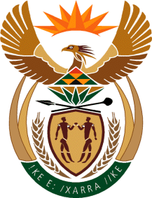

MINISTRY: COMMUNICATIONS
REPUBLIC OF SOUTH AFRICA
Private Bag X 745, Pretoria, 0001, Tel: +27 12 473 0164 Fax: +27 12 473 0585
Tshedimosetso House,1035 Francis Baard Street, Tshedimosetso House, Pretoria, 1000

NATIONAL ASSEMBLY
QUESTION FOR WRITTEN REPLY
QUESTION NUMBER: 2511 of 2015
DATE OF PUBLICATION: SEPTEMBER 2015
Mr W M Rabotapi (DA) to ask the Minister of Communications:
(a) What amounts did the Tshwane TV receive from the City of Tshwane Metropolitan Municipality (a) in the form of sponsorships and (b)(i) for advertising and (ii) any other specified service it provided to the specified metropolitan municipality in the 2013-14 financial year?

REPLY: MINISTER OF COMMUNICATIONS
The Department has no knowledge of support received by Tshwane TV from the City of Tshwane Metropolitan Municipality.

MR NN MUNZHELELE
DIRECTOR GENERAL [ACTING]
DEPARTMENT OF COMMUNICATIONS
DATE:

MS AF MUTHAMBI (MP)
MINISTER OF COMMUNICATIONS
DATE:

