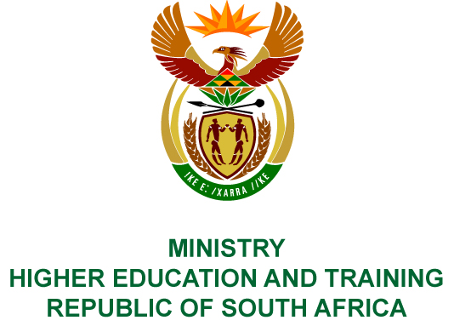
Private Bag X893, Pretoria, 0001, Tel: 012 312 5555, Fax: 012 323 5618
Private Bag X9192, Cape Town, 8000, Tel: 021 469 5150, Fax: 021 465 7956
MEMORANDUM FROM THE PARLIAMENTARY OFFICE
NATIONAL ASSEMBLY
FOR WRITTEN REPLY
QUESTION 251
DATE OF PUBLICATION OF INTERNAL QUESTION PAPER: 15/02/2019
INTERNAL QUESTION PAPER NO 02 OF 2019
Ms N Nolutshungu (EFF) to ask the Minister of Higher Education and Training:
What is the projected number of teachers that will graduate from the higher education institutions in each of the next three academic years?

NW262E
REPLY:
The targeted number of teacher education graduates for 2019 as approved in the mid-term review of the Enrolment Plan (2014 to 2019) is 20 414.
Universities are currently working on their new enrolment plans for the period 2020 to 2025 for approval by their Councils. These plans are due to be submitted to the Department on
15 April 2019 for consolidation and finalisation. Once the enrolment planning statement has been approved by the Minister, the enrolment and graduate targets for the next period will be made available.

