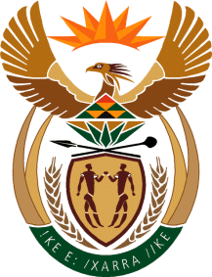

MINISTRY OF TOURISM
REPUBLIC OF SOUTH AFRICA

Private Bag X424, Pretoria, 0001, South Africa. Tel. (+27 12) 444 6780, Fax (+27 12) 444 7027
Private Bag X9154, Cape Town, 8000, South Africa. Tel. (+27 21) 469 5800, Fax: (+27 21) 465 3216

NATIONAL ASSEMBLY:

QUESTION FOR WRITTEN REPLY:
Question Number: 250
Date of Publication: 17 February 2023
NA IQP Number: 2
Date of reply:

Ms H Ismail (DA) to ask the Minister of Tourism:

Whether a proper financial feasibility study was done before finalising the Tottenham Hotspur deal; if not, why not; if so, what are the relevant details? NW254E

REPLY:

I do not have any official information about this matter as yet. I have requested an official
report from SA Tourism, so that I can appraise myself about this matter.

