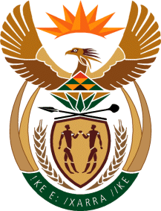

MINISTER IN THE PRESIDENCY: REPUBLIC OF SOUTH AFRICA
Private Bag X1000, Pretoria, 0001, Union Buildings, Government Avenue, PRETORIA
Tel: (012) 300 5200, Website: www.thepresidency.gov.za

NATIONAL ASSEMBLY

QUESTION FOR WRITTEN REPLY

QUESTION NUMBER: 250

Ms N V Mente (EFF) to ask the Minister in The Presidency:
Whether he and/or the Office of The Presidency has bought advertising space in The New Age in the (a) 2012-13, (b) 2013-14 and (c) 2014-15 financial years; if so, (i) what number of times and (ii) for what amount in each specified financial year? NW254E
REPLY:

The Presidency and the Department of Planning Monitoring and Evaluation did not buy advertising space in The New Age newspaper in the period in question.

