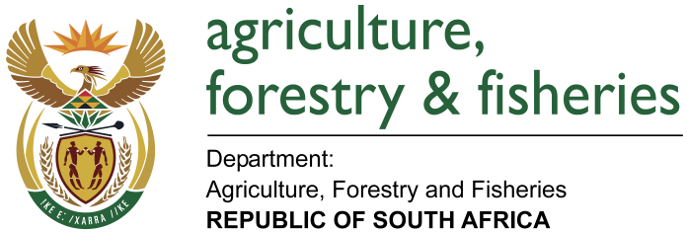
NATIONAL ASSEMBLY

WRITTEN REPLY

QUESTION 2499 / NW 2756

MINISTER OF AGRICULTURE, FORESTRY AND FISHERIES:
Mr P van Dalen (DA) to ask the Minister of Agriculture, Forestry and Fisheries:

QUESTION:

- What are the relevant details of all products produced by the Camdeboo Satellite Aquaculture Project since its inception,

- how many of the specified products were: (i) produced and (ii) sold and

- What is the value of the product sales to date?

REPLY:
a) The Camdeboo Satellite Aquaculture Project has undergone a lengthy proof of concept, pilot and due diligence stage and is set to start Phase 1 of commercialisation in September 2017.

b) The facility currently produces the following innovative products at a small interim processing facility in Graaff-Reinet which is still undergoing construction amendments in order to receive relevant approval to sell frozen products and therefore is restricted to sale of fresh produce in the local area at present.
• Fish wors
• Fish burger patties
• Smoked fish fillets
• Fresh fish fillets
• Whole smoked fish
• Fish mince

c) Given the abovementioned constraints, and the fact that the vast majority of processing has been for product development / refinement, marketing activities and to obtain the necessary authorisations, sales to date have been minimal and amount to a mere
R 144,403.00. The facility does have letters of in place, which will be converted to offtakes as soon as commercialisation commences. The facility is open to providing Parliament with product samples for tasting at their earliest convenience.

