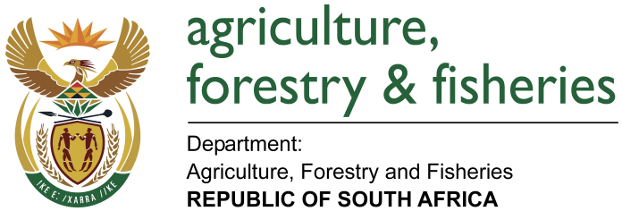
NATIONAL ASSEMBLY

WRITTEN REPLY

QUESTION 2498 / NW 2755E

MINISTER OF AGRICULTURE, FORESTRY AND FISHERIES:
Mr P van Dalen (DA) to ask the Minister of Agriculture, Forestry and Fisheries:

QUESTION:
(1) Whether his department has disbursed any monies to a certain trust (name furnished) and/or a certain project (name furnished) in each of the past three financial years; if so, (a) who is/are the project leader(s), (b) what is the total amount that has been disbursed and (c) from which programmes were the funds sourced in each case;
(2) Whether his department has records of a full account of how the specified (a) trust and (b) project have spent the money; if not, in each case, why not; if so, (i) what are the relevant details of expenditure in each case and (ii) of this, how much was spent on (aa) marketing research and (bb) infrastructure development in each case? NW2755E
REPLY:
- The Department of Agriculture, Forestry and Fisheries has not disbursed any funds to the Blue Karoo Trust and/or Camdeboo Satellite Aquaculture Project in three financial years, i.e. 2015/16; 2016/17 and 2017/18.
- The Department of Agriculture, Forestry and Fisheries has not provided financial support to the project in three financial years i.e 2015/16; 2016/17 and 2017/18, therefore does not have any financial records in that regard.

