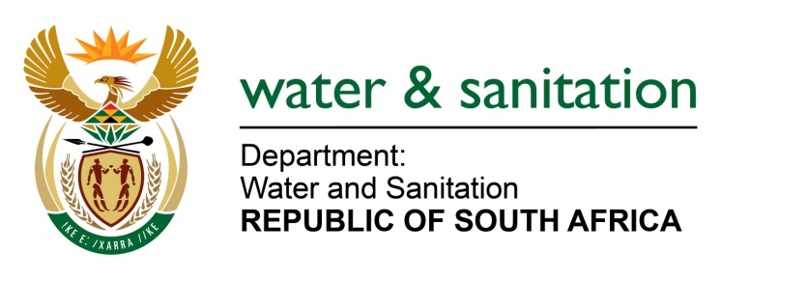

NATIONAL ASSEMBLY

FOR WRITTEN REPLY

QUESTION NO 2491

DATE OF PUBLICATION IN INTERNAL QUESTION PAPER: 26 AUGUST 2022
(INTERNAL QUESTION PAPER NO. 27)

2491. Mr P Mey (FF Plus) to ask the Minister of Water and Sanitation:

- (a) What (i) total number of employees of his department are currently working from home, (ii) number of such employees have special permission to work from home and (iii) are the reasons for granting such special permission and (b) on what date will such workers return to their respective offices.

(2) Whether he will make a statement on the matter?

NW2939E
---00O00---

MINISTER OF WATER AND SANITATION

- (a) (i) None.
(ii) Not applicable.
(iii) Not applicable.

(b) Not applicable.

- No. there is no need to make a statement. The Department implemented the provisions of DPSA Circular no 38 of 2022 dated 29 June 2022.

---00O00---

